**NLP Final Project Report**



## Detection of SPAM in Email

## Presented By

## Rithika Gurram

## Likhith Kolli

## Professor Mr. Larche

Introduction:

In the modern era of digital communication, unsolicited and often harmful emails, commonly referred to as spam, pose a significant challenge. They not only inundate users' email accounts but also pose security risks and hinder effective communication channels due to their overwhelming volume. Robust spam detection systems are imperative to filter out unwanted emails and ensure the integrity of electronic correspondence. This study aims to explore the potential of natural language processing (NLP) techniques in developing an effective email spam detection system capable of accurately identifying and categorizing spam emails.

About Dataset:

The project utilizes a carefully curated dataset comprising diverse email samples categorized as either "spam" (unsolicited) or "ham" (legitimate). Various elements such as text, metadata, and structural attributes are extracted from the email content and incorporated into the dataset. Prior to model training, the dataset undergoes thorough preprocessing to refine and standardize the text data, remove extraneous information, and prepare it for feature extraction and analysis. Additionally, exploratory data analysis is conducted to gain insights into the composition of the dataset, the distribution of classes, and any potential challenges encountered. Our dataset consists of 3672 Ham files and 1500 Spam files.

Step1: Import Libraries

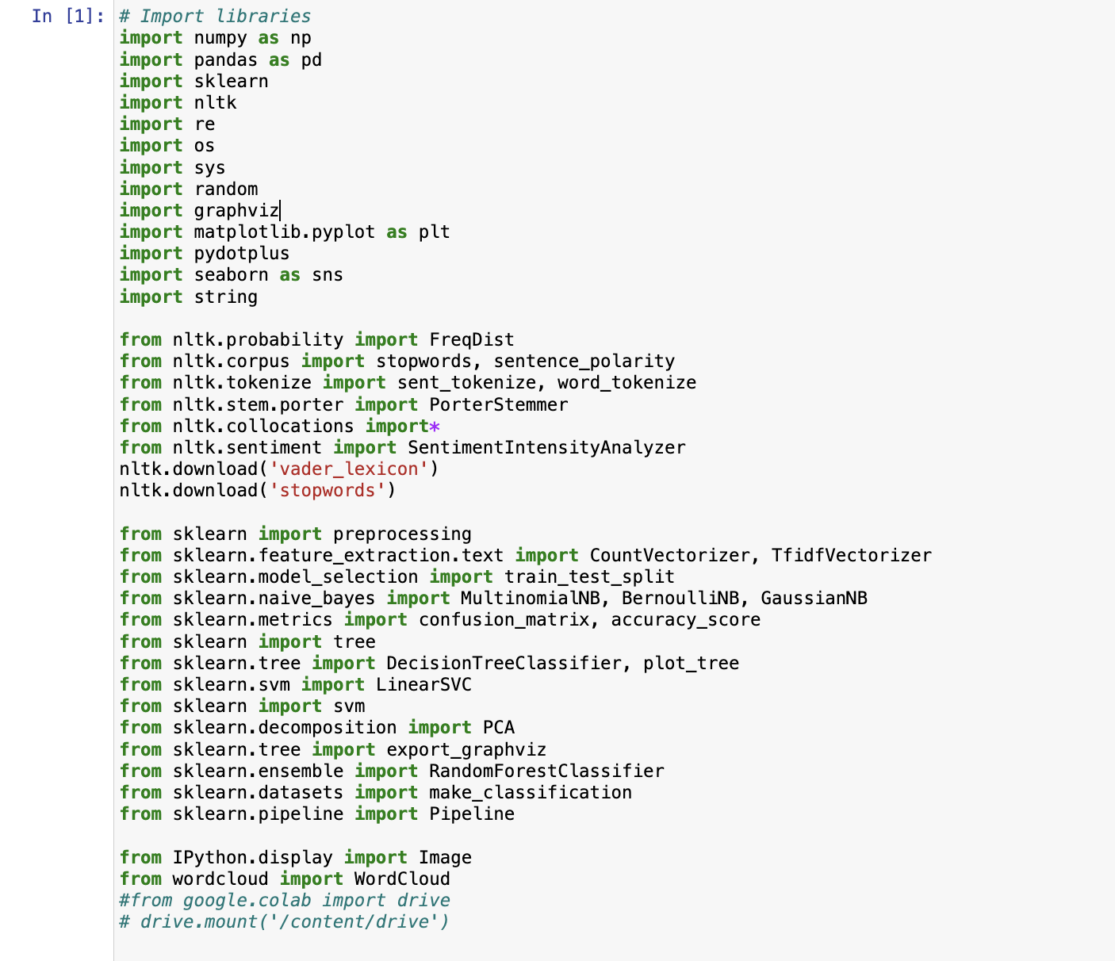

Summary:

This code snippet is a setup block for a project that likely involves heavy data manipulation, analysis, and machine learning, specifically NLP. The libraries imported provide a robust foundation for handling, processing, analyzing, visualizing data, and implementing machine learning models. This setup is typically placed at the beginning of a notebook or script to ensure all necessary functionalities are available for the tasks that follow.

**Step 1:Converting Data for Processing in the processSpamHam Function**

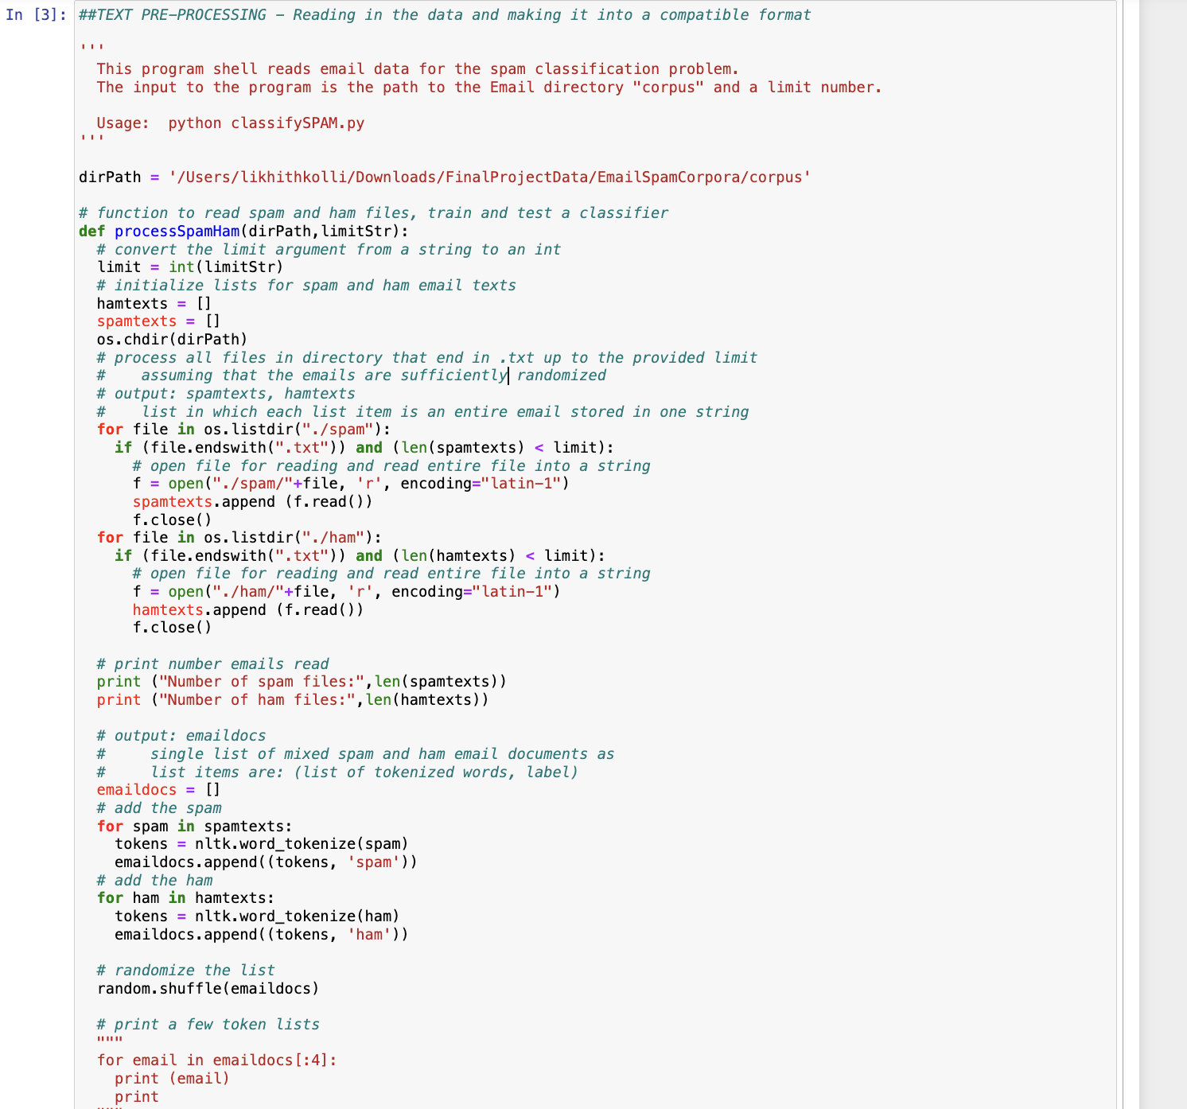

In the processSpamHam function, the team transformed the data from the provided .txt files into a usable format. This process was initiated using the foundational code from the FinalProjectData.zip file. Modifications were made to the original code to generate additional lists, which were necessary for the subsequent stages of data cleaning and filtering. These changes allowed for a more comprehensive preparation of the data, ensuring that it met the requirements needed for later processing tasks.

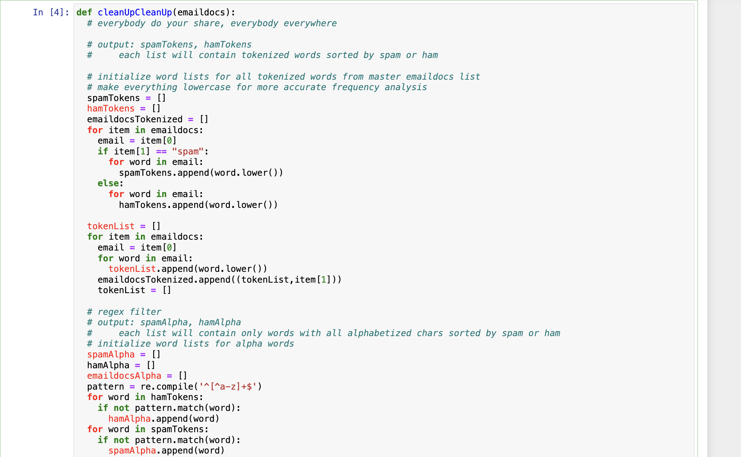

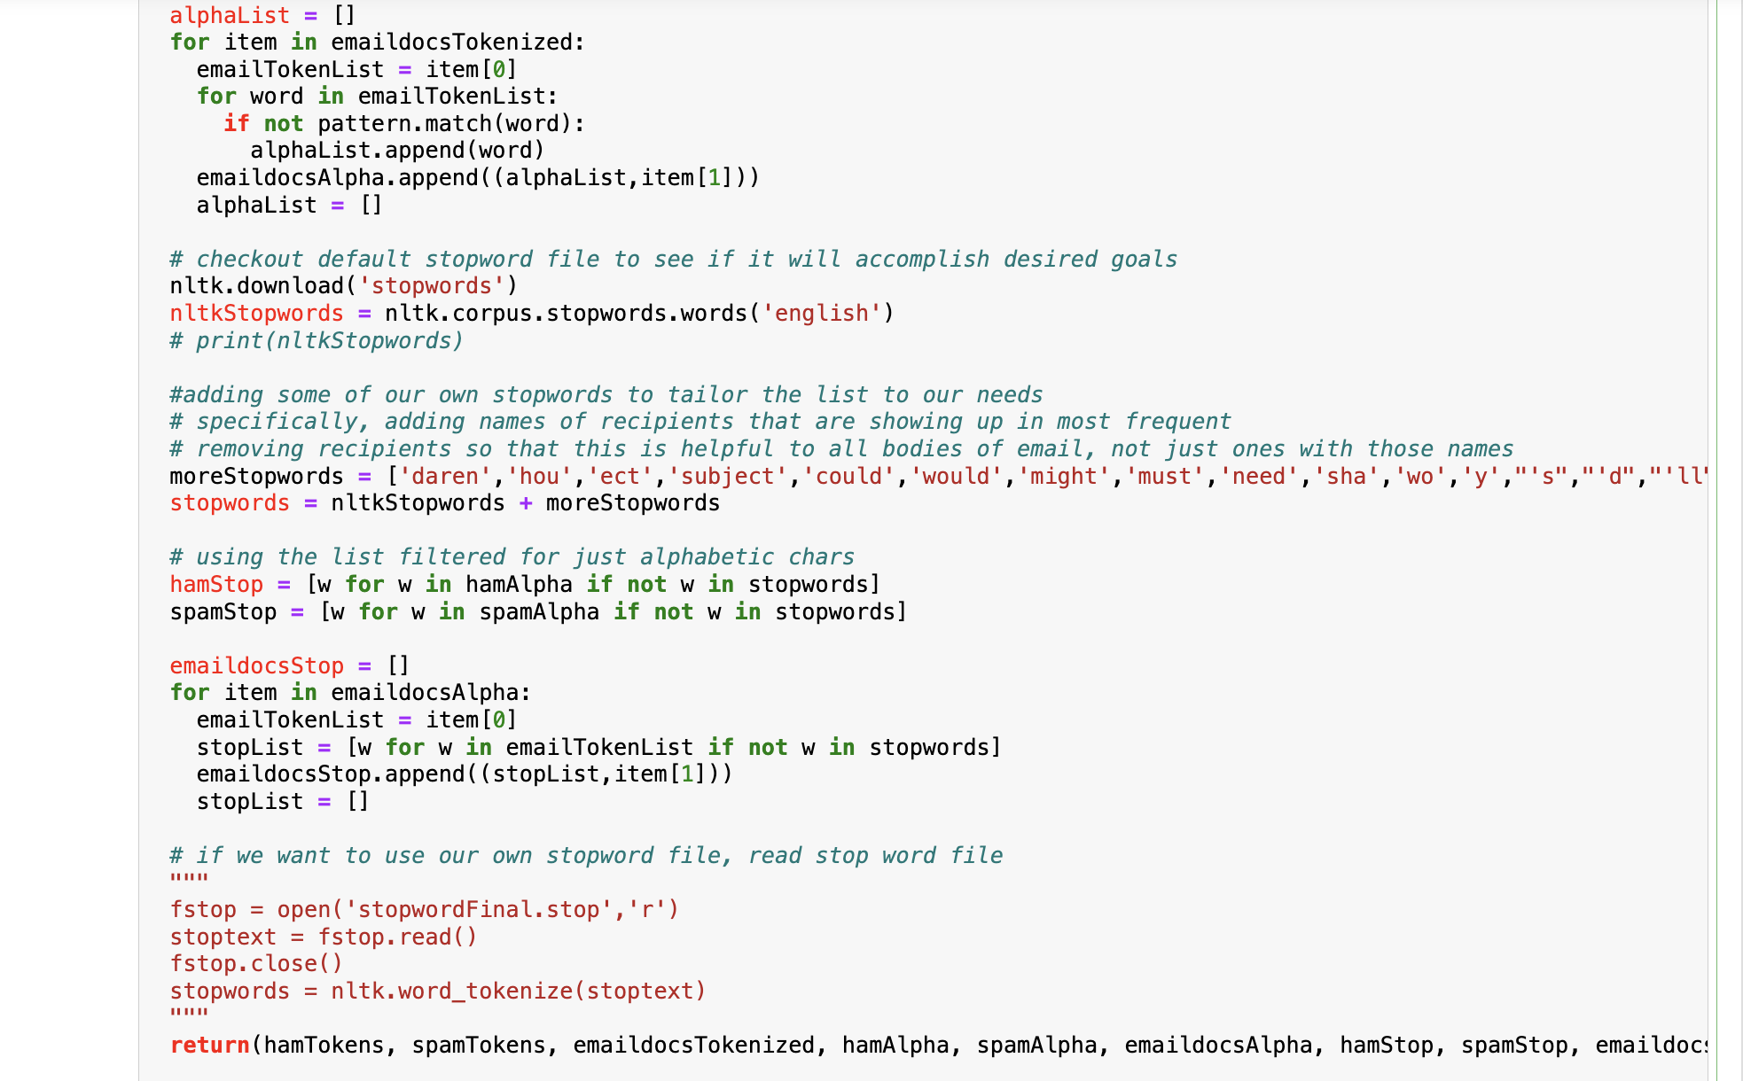

**Tokenizing and Filtering: Lowercasing, Regex, and Stopword Removal**

In the cleanUpCleanUp function, the process begins by converting all email text to lowercase and then tokenizing the text. Following this, the function eliminates all symbols and numbers from the emails. Subsequently, stopwords listed in the "stopwords" list are removed from the email text. The function then produces nine slightly modified lists for subsequent use.

The initial set of lists contains only the tokenized emails, each labeled as "spam" or "ham." One list comprises only ham emails (hamTokens), another contains only spam emails (spamTokens), and a third is a mixed shuffle of both spam and ham emails (emaildocsTokenized).

The second set of lists includes the tokenized emails, stripped of symbols and numbers, and also labeled as "spam" or "ham." This includes a list for ham emails with no symbols or numbers (hamAlpha), one for spam emails (spamAlpha), and another mixed list (emaildocsAlpha).

The third set of lists features the tokenized emails with both symbols/numbers and stopwords removed. These are also labeled as "spam" or "ham."

The team opted for the NLTK-provided "english" stopword list to ensure the classification framework remains effective across different email datasets, not just the ones in this corpus. This broader application is because the NLTK list was derived from a more extensive corpus. Additionally, the team removed common names from the "To:" lines of the emails to prevent the classification system from relying on recipient names, which might not remain a reliable classification criterion if the email dataset changes.

While the default choice was the NLTK "english" stopword list, the team also included commented-out code for loading a specific stopword file if needed.

Like the previous sets, the final three lists after tokenizing, filtering, and removing stopwords include one with only ham emails (hamStop), one with only spam emails (spamStop), and one mixed list (emaildocsStop).

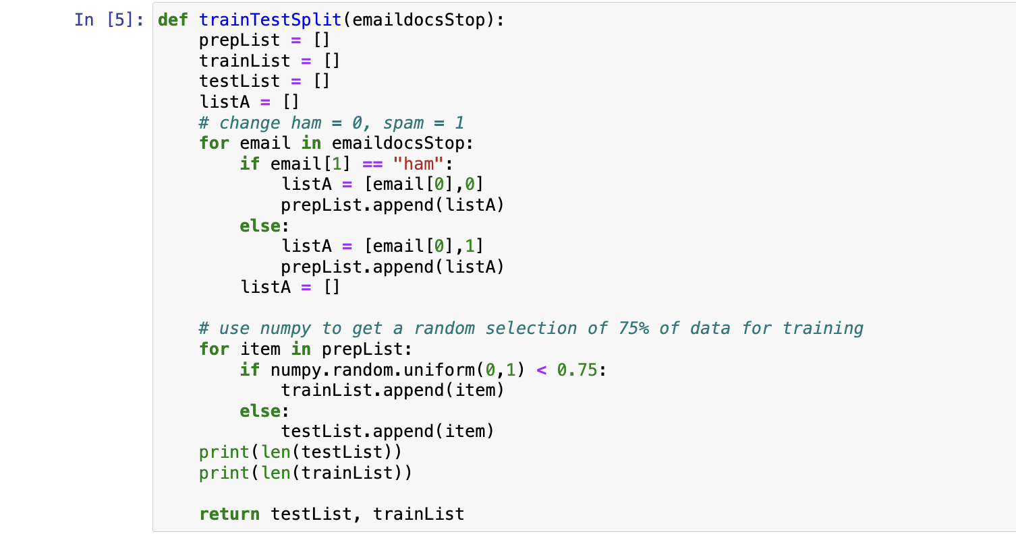

**Splitting Training and Testing Data**

Following the data cleaning process, the team developed several functions to set up the data for classification tasks. To effectively train and test our models, it was necessary to divide the provided corpus into training and testing segments. Using the numpy library, the function randomly selected 75% of the data for training purposes. The remaining 25% was reserved to test the models' accuracy and precision post-training. Additionally, the function converted the labels "spam" and "ham" into numerical values (spam = 1, ham = 0) to accommodate the format required by the classifiers. A list of lists was then created to store the emails and their numerical labels, with each email's tokens as one element and its corresponding numerical label (1 or 0) as another. The function ultimately generates two lists upon completion: testList for testing data and trainList for training data.

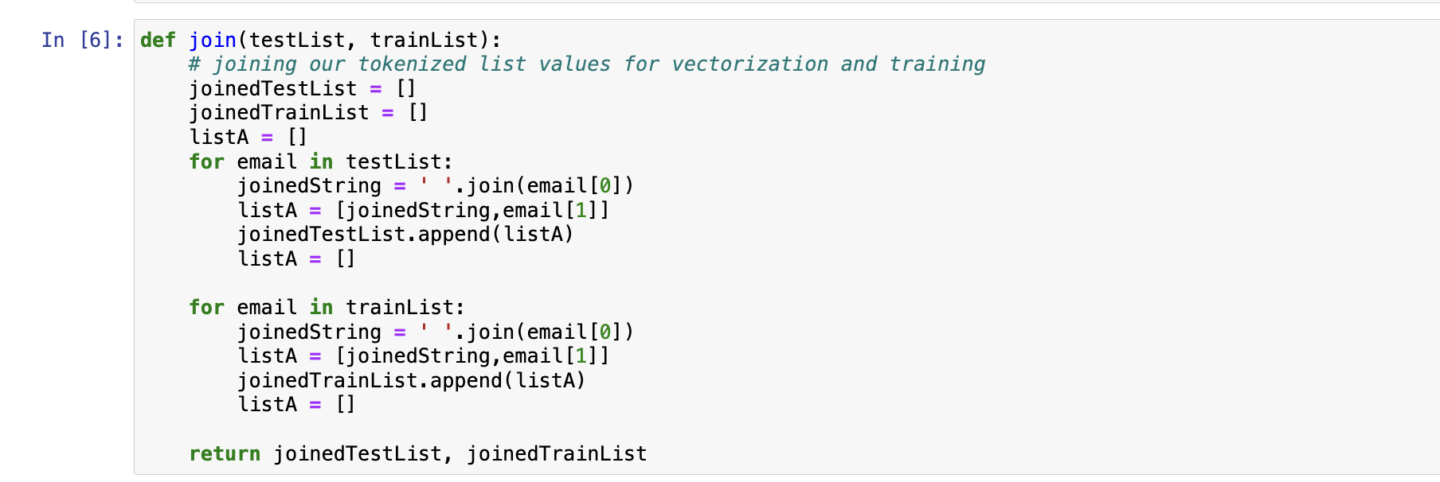

**Rejoining Tokenized Emails**

The sklearn modules selected by the team for training our classification models necessitated that the emails be formatted as a continuous string for processing. To preserve the data manipulation already performed (such as filtering, stop word removal, and conversion to lowercase), the team reassembled the tokenized and cleaned emails back into single strings. This function accepts a vectorized list and outputs a list comprising continuous email strings alongside their respective labels, thereby ensuring compatibility with the classification tools used in our models.

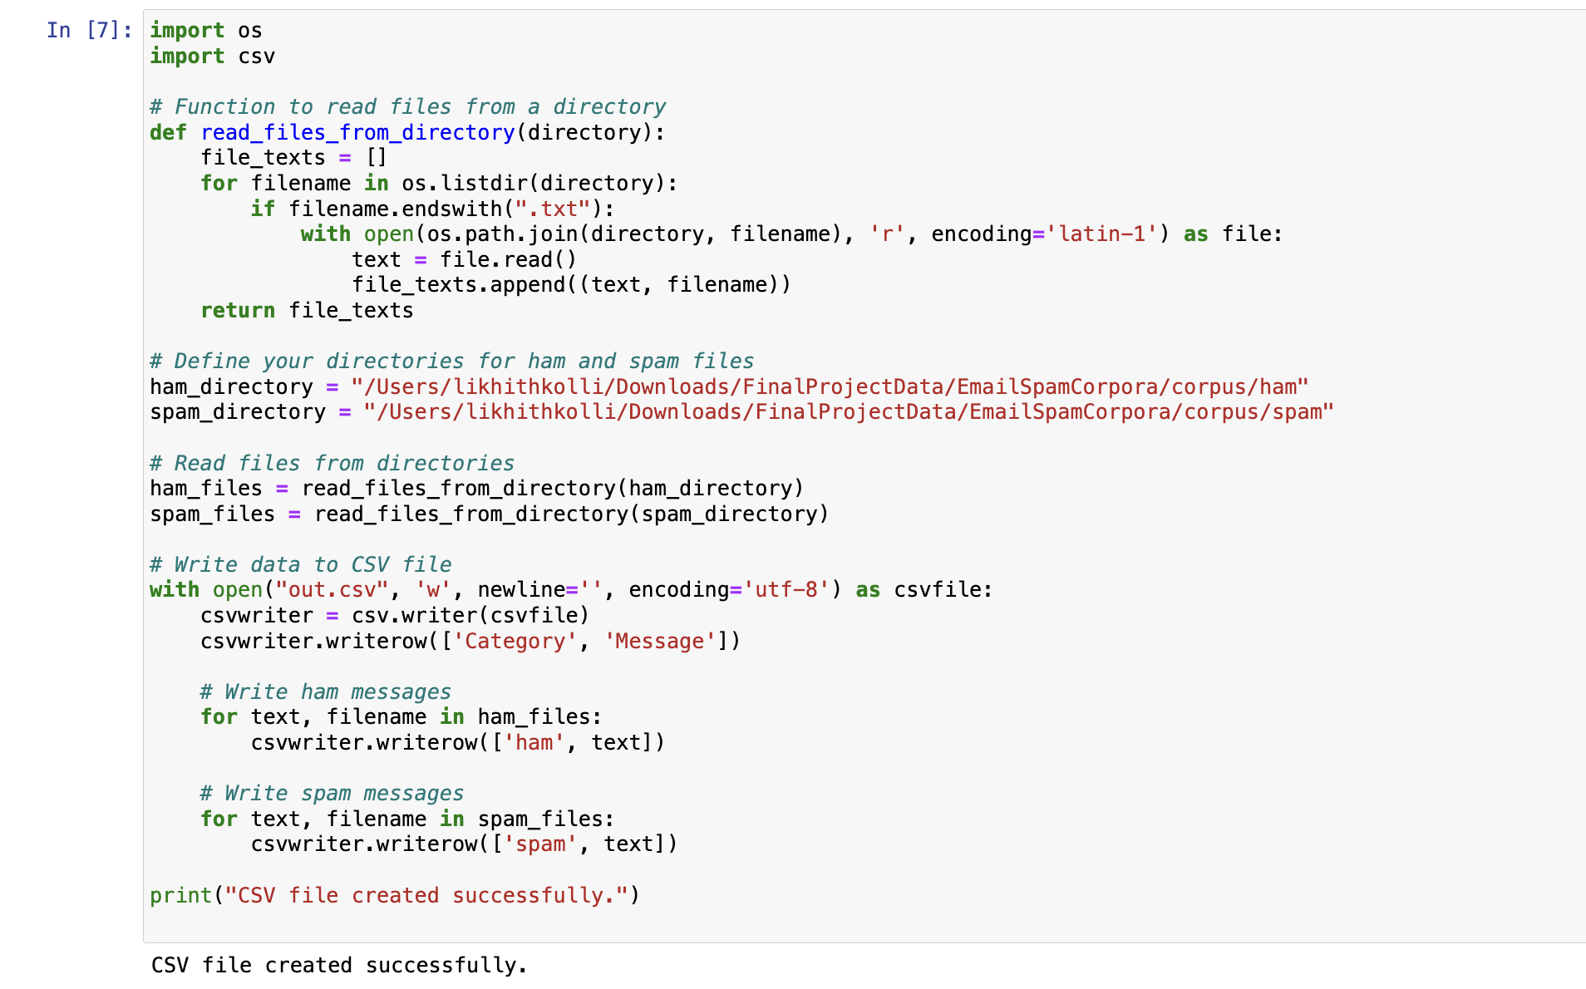

**Exporting Data to CSV for TensorFlow Processing**

To facilitate the use of TensorFlow, which operates most efficiently with data in CSV format, the team utilized the pandas library to write our processed data to the "out.csv" file. This setup allows for convenient later processing using TensorFlow, ensuring that the data is structured in a way that is optimal for training and deploying machine learning models. This method provides a seamless transition from data preprocessing to model training and evaluation within the TensorFlow framework.

**STEP 2: FEATURE ENGINEERING**

Constructing Feature Functions for Data Analysis and Classification

Once the data was processed and cleaned, the team developed a range of feature functions. These functions served to highlight different characteristics of the data and also to generate more targeted datasets for the classification tasks. The feature functions were crucial in providing insights into the data's attributes and in preparing it for effective model training. Additionally, to document and demonstrate the functionality and outcomes of these feature functions, the team included screenshots of the code execution. This visual documentation helps in understanding the impact and utility of the implemented features within the classification processes.

**Feature 1: Frequency Analysis**

Feature 1 is designed to perform frequency analysis on any tokenized list provided to it. The primary function of this feature is to identify and print out the top 30 most commonly used words from each list. This analysis helps in understanding the predominant vocabulary within different datasets, which can be particularly useful in discerning patterns or biases in the data, such as the prevalence of specific terms in spam versus ham emails. By focusing on the most frequent words, this feature provides a clear snapshot of key textual elements that might influence classification outcomes.

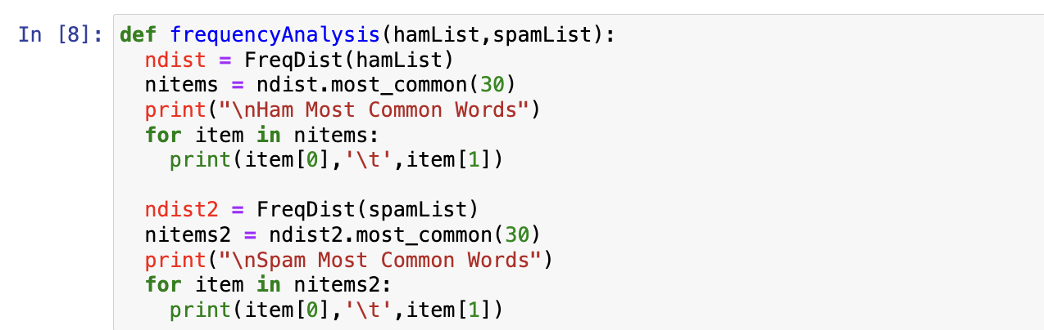

In def main(), the following code was used to return the results displayed in the screenshot:

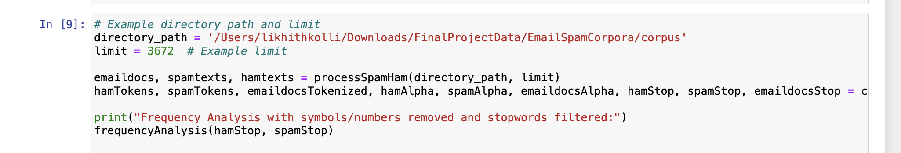

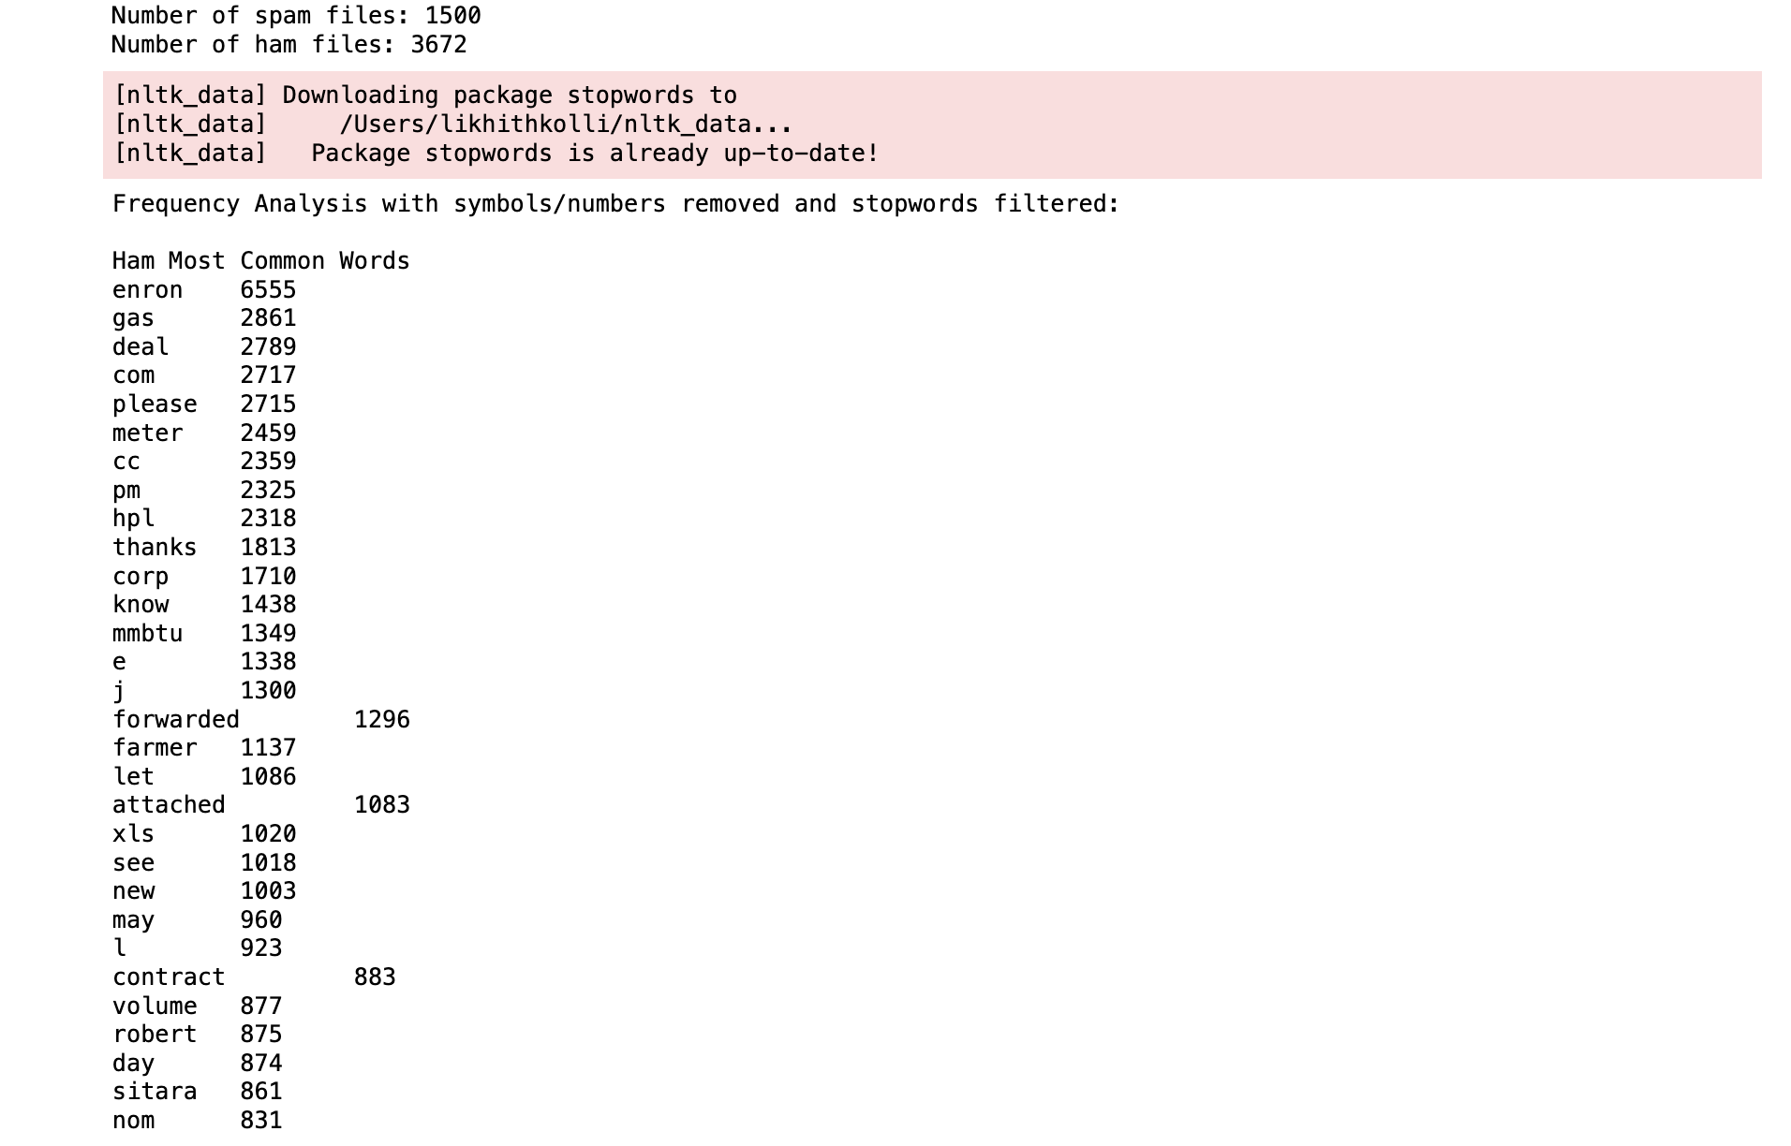

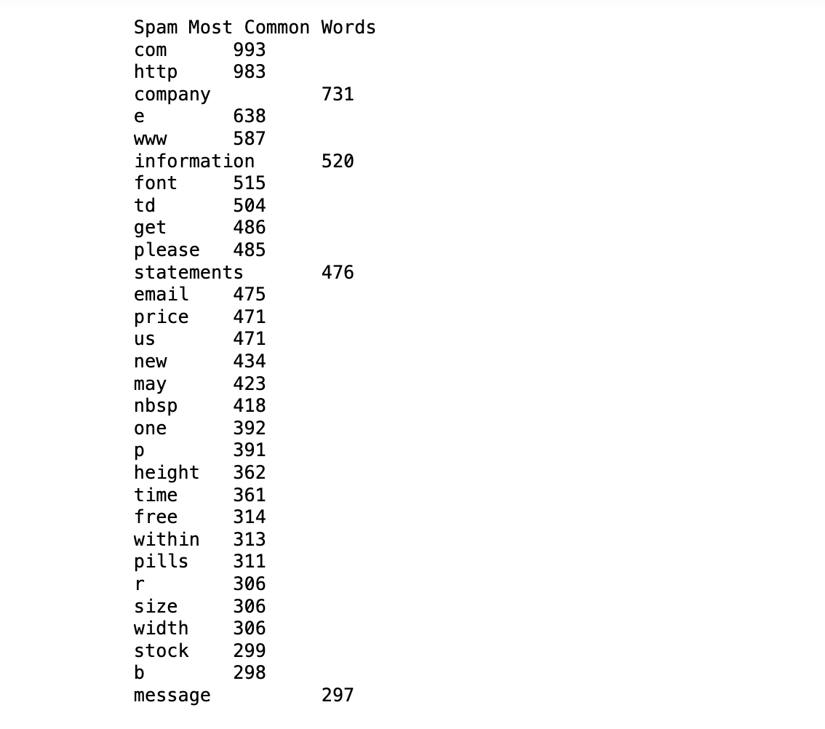

That's a fascinating observation from your frequency analysis! It seems like the common words in HAM emails reflect specific industry language, in this case, terms typical for a gas company, which likely includes technical and business-related vocabulary. On the other hand, the prevalence of words like "pills" among the top words in SPAM emails, along with other seemingly random terms, highlights how SPAM often focuses on certain products or misleading links (indicated by "com" and "http").

This kind of analysis is crucial for developing effective spam filters or classification models, as identifying such distinctive keywords can significantly enhance the accuracy of distinguishing between SPAM and HAM. Words like "pills" serve as strong indicators of SPAM, especially when they appear frequently in unsolicited emails. This insight could be very useful in tweaking algorithms or setting rules for more refined email filtering.

**Feature 2: Bigram Creation and Frequency Analysis**

Feature 2 takes in an tokenized list and returns the top 30 most common bigrams from the list.

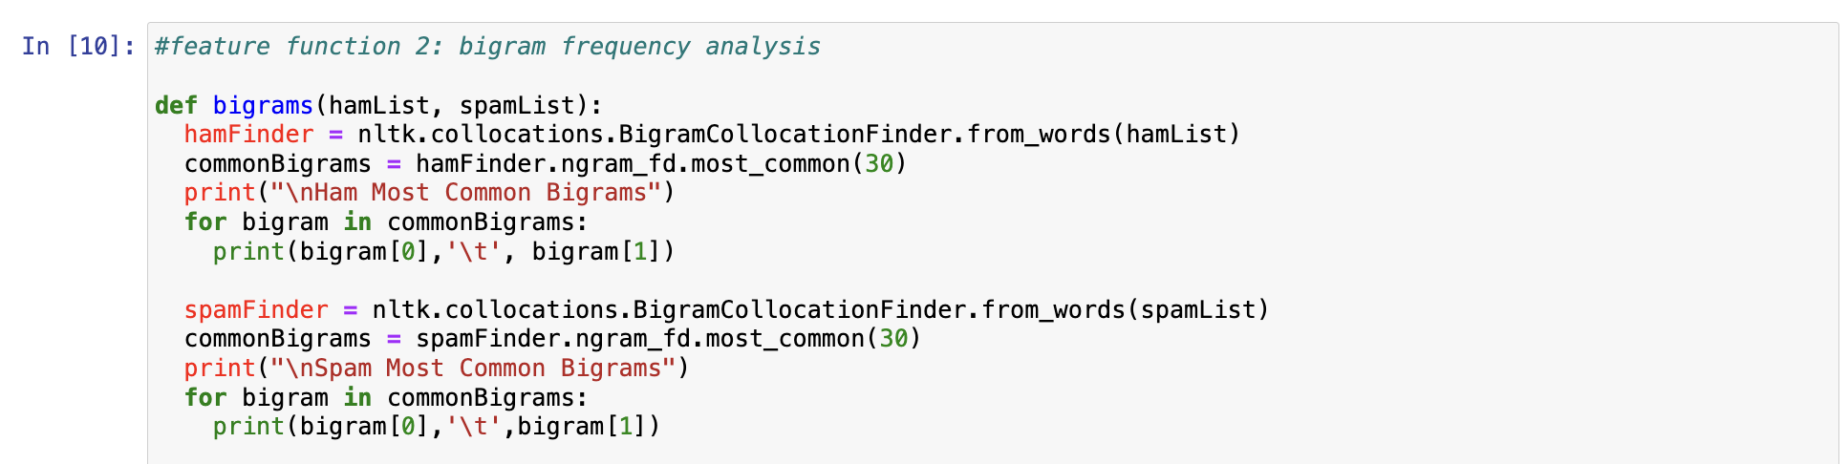

In def main(), the following code was used to return the results displayed in the screenshot:

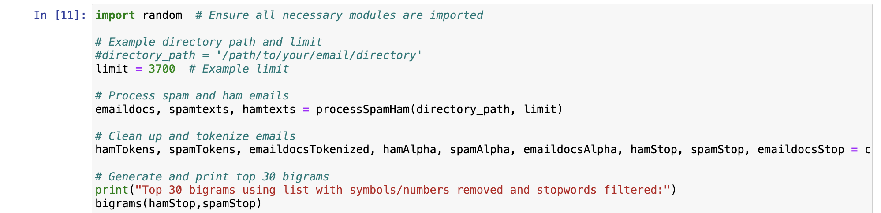

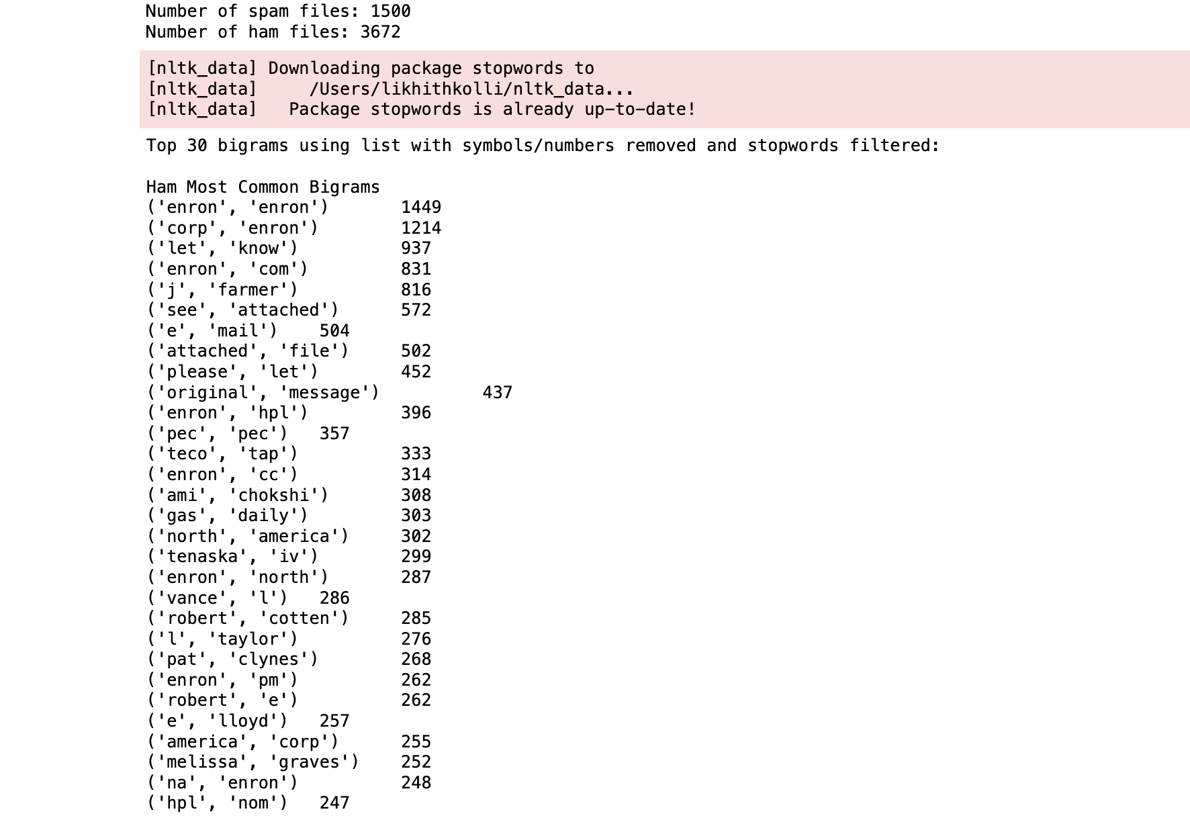

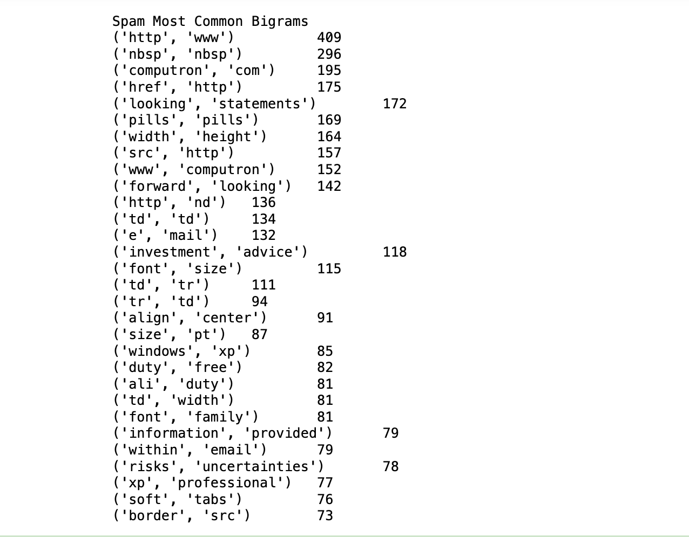

Analysis of bigrams from the cleaned and filtered data provides insightful observations into the linguistic strategies employed in SPAM and HAM emails. The SPAM-associated bigrams here mentioned, like (href, http), (http, www), and (investment, advice), indeed suggest an attempt to mimic official or authoritative language. This tactic aims to exploit the recipients' trust, persuading them to click on seemingly legitimate links that might lead to phishing sites or other fraudulent activities.

The appearance of the bigram "risks, uncertainties" in HAM emails interestingly contrasts with the SPAM strategies, possibly indicating more grounded and realistic communication often found in legitimate business or informational exchanges. These phrases in HAM emails might reflect a more careful and detailed approach to communicating potential issues or considerations, which is typical in formal and professional correspondences.

The point about the potential consistency of SPAM phrases across different datasets is particularly important for developing anti-spam measures, as it suggests certain linguistic patterns can be reliably used for detection regardless of the specific data set. Conversely, the variability of HAM bigrams across different companies or authors highlights the challenges in distinguishing these emails from SPAM when the linguistic content shifts significantly due to the context or sector-specific language.

This analysis can greatly enhance the effectiveness of spam filters by incorporating these insights into their algorithms, allowing them to better differentiate between malicious and benign emails based on linguistic patterns.

**Feature 3: Trigram Creation and Frequency Analysis**

Feature 3 takes in an tokenized list and returns the top 30 most common trigrams from the list.

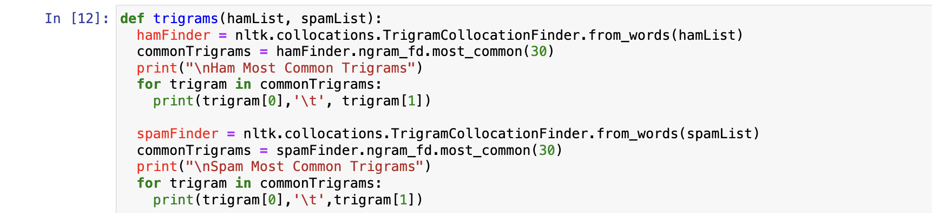

In def main(), the following code was used to return the results displayed in the screenshot:

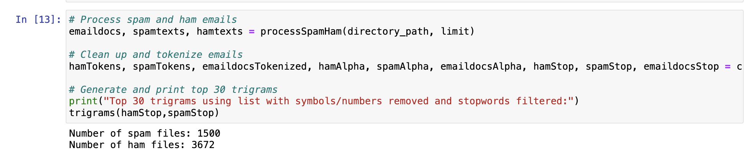

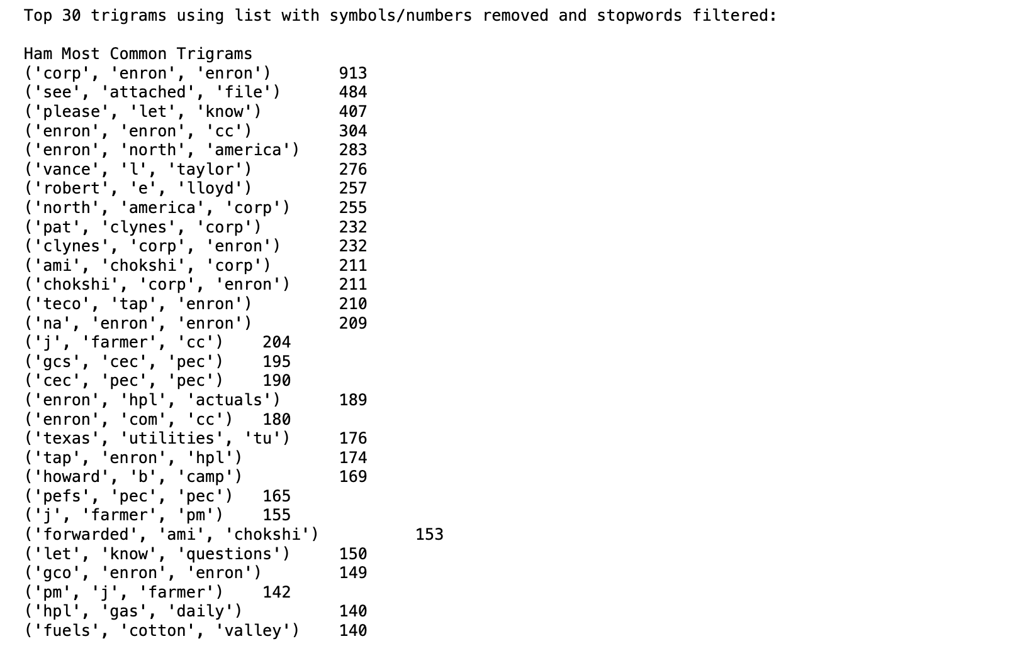

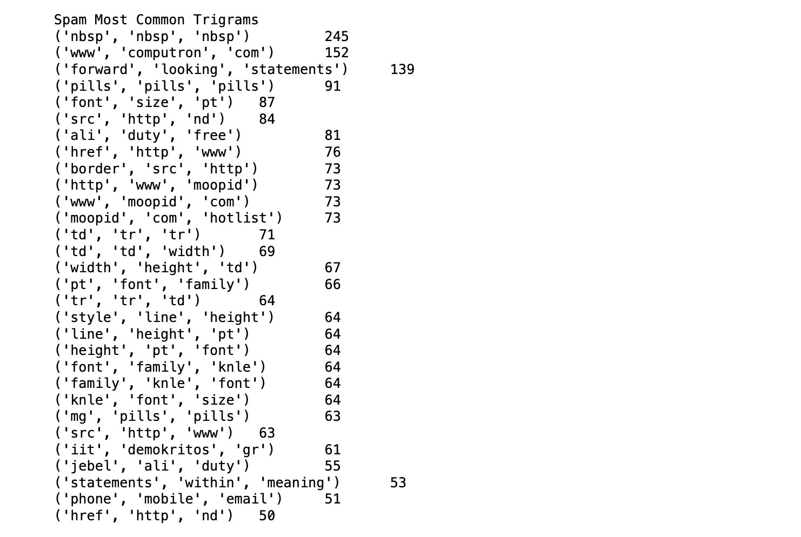

This screenshot shows the trigrams using the cleaned and filtered data lists. The analysis of the trigrams remains consistent with that of the bigrams: the most common spam phrases are expected and will likely remain consistent across datasets. However, the most common ham trigrams are specific to the content and origin of the ham corpus of emails.

**Feature 4: Sentiment Analysis**

Feature 4 uses the sentiment intensity analyzer included in the NLTK to score each email's sentiment. The SIA returns various types of sentiment scores using the VADER module. In this feature, the team chose to focus on the compound score to separate positive and negative emails. If an email's compound score is greater than 0, it is classifed as positive. If it is less than 0, it is negative. It returns a list of tuples with the email, the compound score, and it's label of "positive"/"negative."

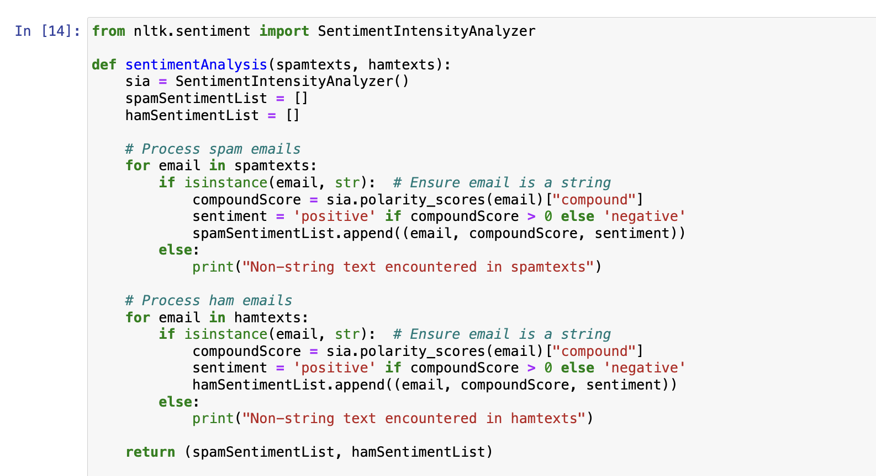

In def main(), the following code was used to return the results displayed in the screenshot:

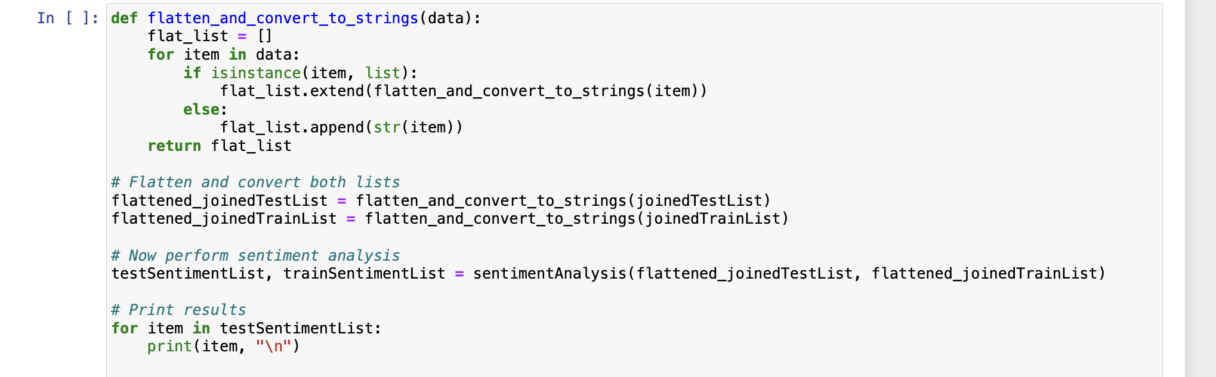

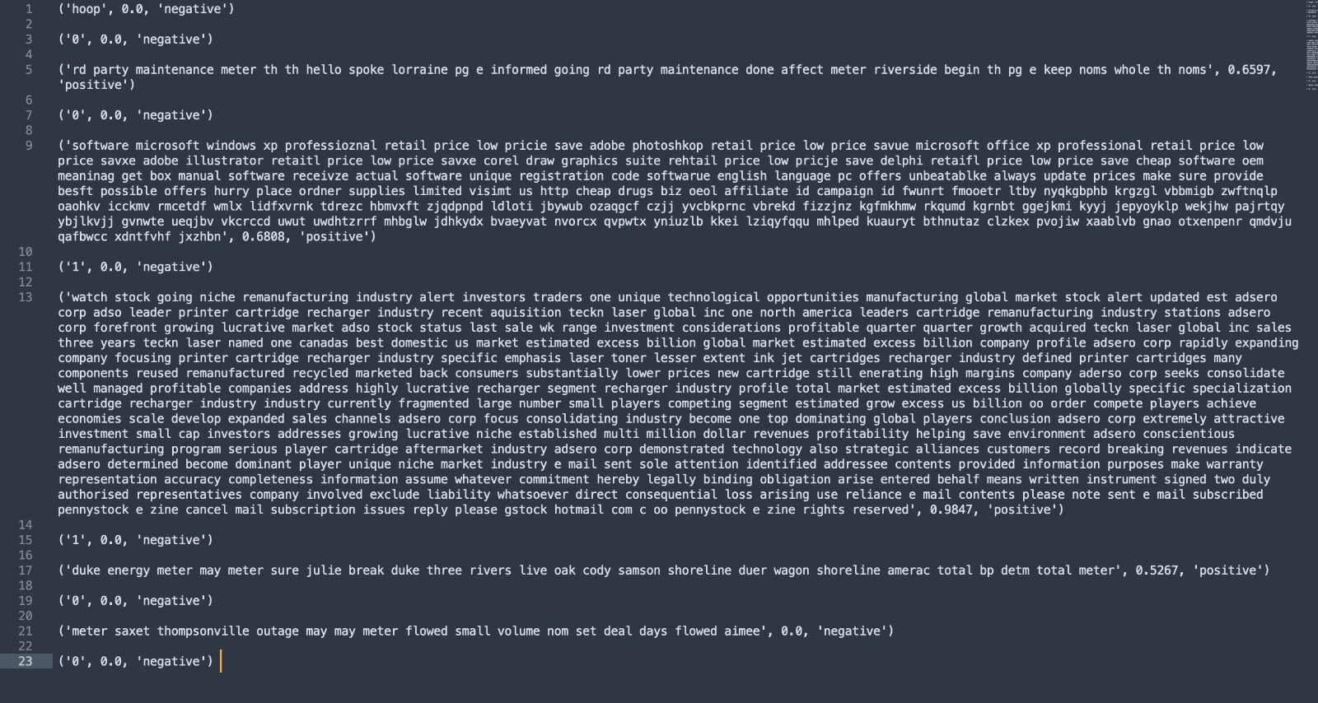

**STEP 3: EXPERIMENTS**

**Text Classification Experiments**

**Multinomial Naive Bayes**

An example of using an Sklearn classifier with features produced in NLTK. The classifier being Multinomial Naive Bayes and the produced features are the numerical representations of the text data being ran through MNB that were produced using CountVectorizer. The process of MNB is as follows: each document, in this case each text/email file, is converted into a list of features, i.e. words, and then the number of times that unique word is present in all of the texts is recorded, and a data frame of these frequencies is created. In this case, every column in the data frame is a unique word that appears in 1 or more text files. The corresponding rows contain whether or not that word appears in the text file it is counting for and there is a label column that contains either "spam" or "ham" in the training data, which MNB will use to predict classifications. The output prediction is the model's probability that each set of words would belong to spam or ham. MNB is a good choice for our task because it is both efficient and simple, and effective working with text data. It also usually performs well and the output is easily readable. In pre-processing this set of data, in order to run MNB in a timely fashion, a random sample of the data was selected and used. Without taking a random sample, it was ran for over 24 hours and ultimately the computer did not have enough memory. As for cleaning the new set, first, the data is stemmed and made lowercase. Below, a stemmer function was created. Stemming was not done for the other experiments, and was used in this case simply out of curiosity and a desire to see its effect, if any, on the outcome of accuracy and prediction. Pre-processing is extremely important for running MNB because it does take a very long time to run and cutting down on running extraneous words is helpful. For example, it is easier to run "sit", instead of all four of the following: "sat", "sitting", "sits", and "Sit."

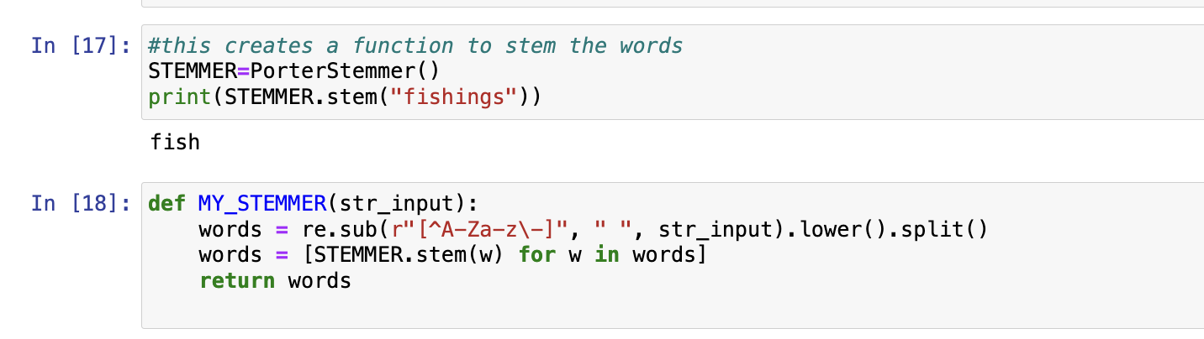

Next, a vectorizer was set up using CountVectorizer, that also included removing stop words, making all words lowercase for consistency and decreasing the amount of duplicate tokens, stemming, and tokenizing.

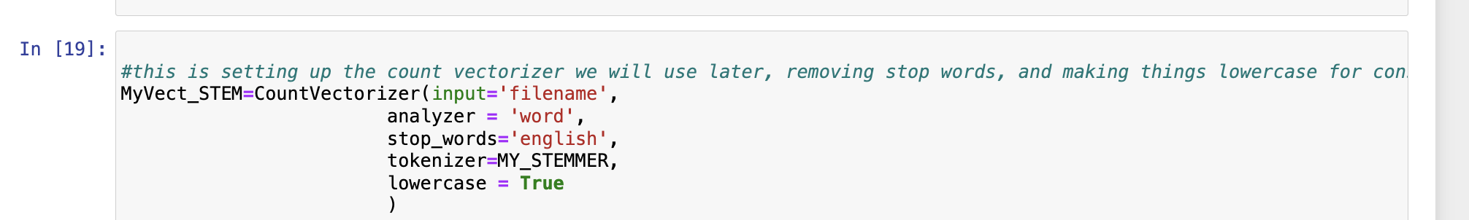

A function was created to remove all numbers that would be a column in the vectorized data frame just to see its effect on the accuracy and prediction, and simply as another cleaning step as much of the data included extraneous material and symbols.

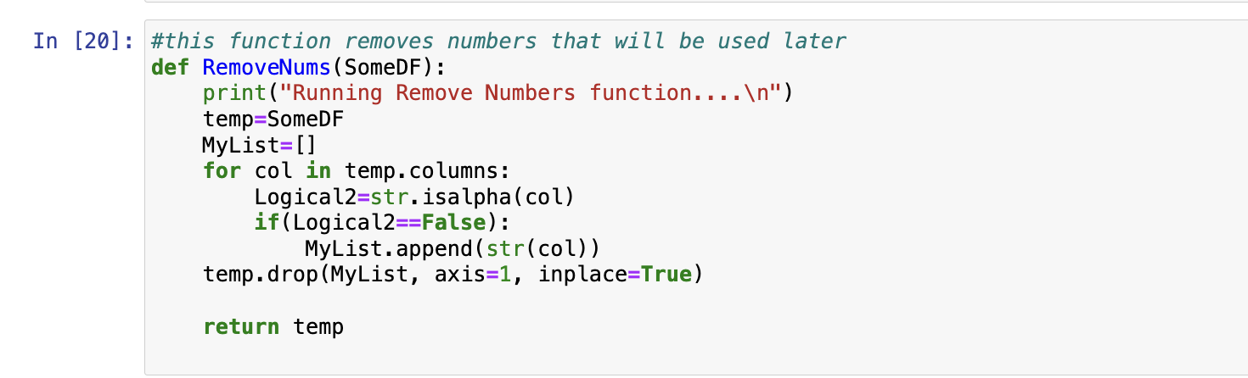

An empty data frame is established that will then house the vectorized data frame.

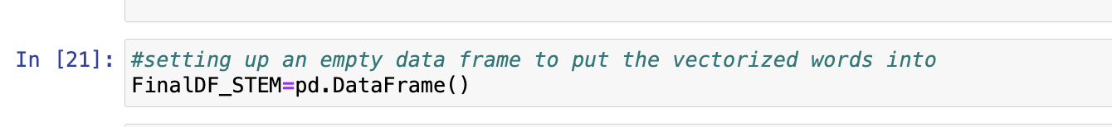

Below is where the data is read in , cleaned, and vectorized simultaneously. One of the columns is "label" which is "spam" or "ham" indicating which classification each email has, and the words in these emails is indicated with a number, "1.0" for its inclusion or "0.0" if not.

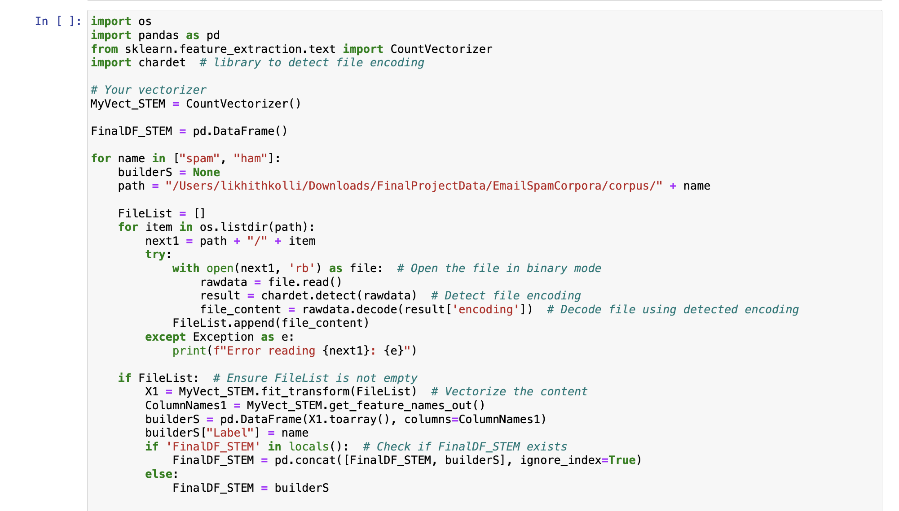

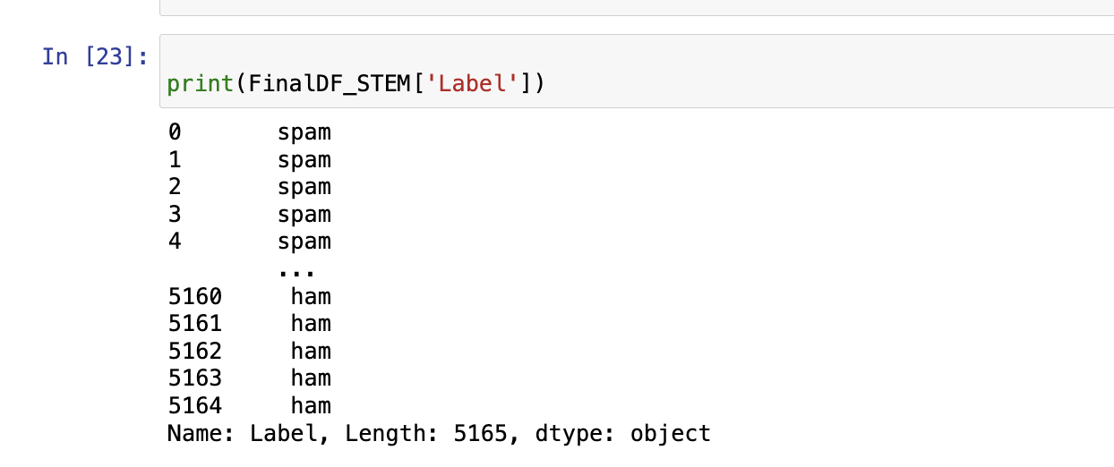

More cleaning is done below, removing NAs, removing numbers, and then the training and test data is split 70/30.

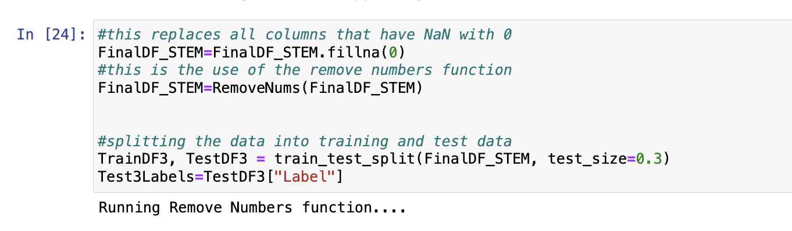

Below, the label column is removed in order to use MNB, otherwise it would not run.



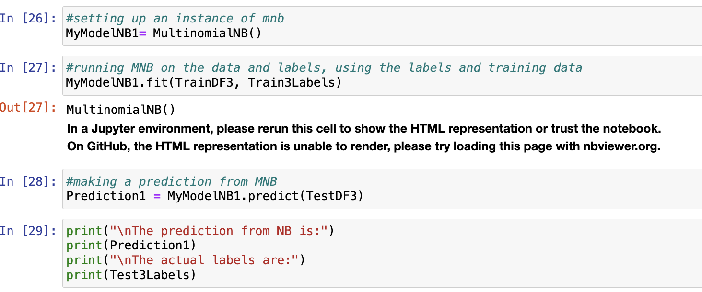

Below is the prediction that would go on for many rows, so only a snippet is shown. A glimpse can be seen of the accuracy of the model given that the model accurately predicted all 6 of the predictions shown below.

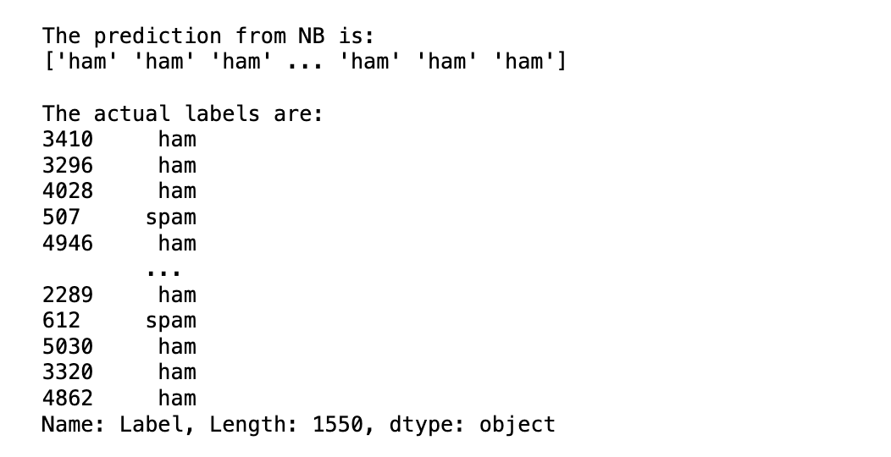

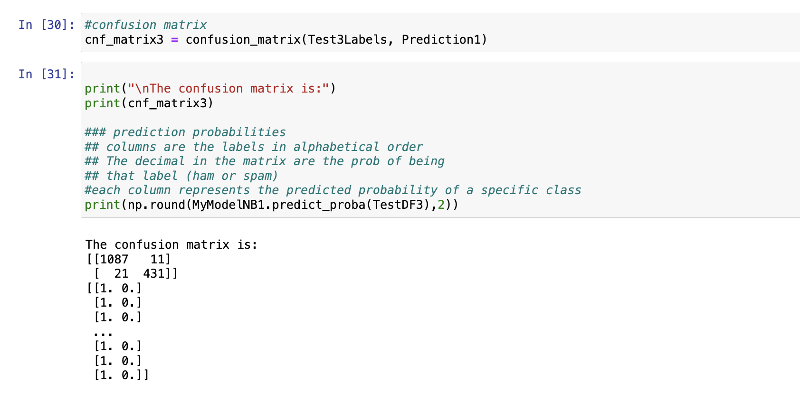

The results: there were 1087 emails correctly classified as not spam, 21 non-spam emails incorrectly classified, and 431 spam emails correctly classified. However, it is to be noted that there were 0 incorrectly classified instances for non-spam emails, this might also indicate overfitting of the model and reduces its effectiveness in evaluating the difference between spam and ham emails.

**Classification Function: Gaussian NB, Multinomial NB, Bernoulli NB**

Vectorizers: bag of words, TFIDF

Classifiers: GaussianNB, MultinomialNB, BernoulliNB

This function takes the processed, cleaned, re-joined, and train/test split lists as input (joinedTestList, joinedTrainList). Additionally, it accepts a string that specifies the vectorizer type (bag of words, TFIDF) and the classifier type (GaussianNB, MultinomialNB, BernoulliNB).

In our initial classification experiments, the team chose to use sklearn to vectorize our corpus data and train/test our models.

This function splits the input list values into X and Y data sets: X = email data, Y = label data. It feeds the training data into the vectorizer to return a 2-D document-term matrix. It then transforms the matrix into a dense array because that is the format required for using the training data to fit the classifier. The specified classifier is trained using the email data and labels. Next, the model's accuracy is tested by using the remaining test data. The classifier.predict module gets the model's predictions for the email classification, and, finally, we compare the predictions with the actual spam/ham classification.

The function returns a trained classifier to use in our cross fold validation experimenting.

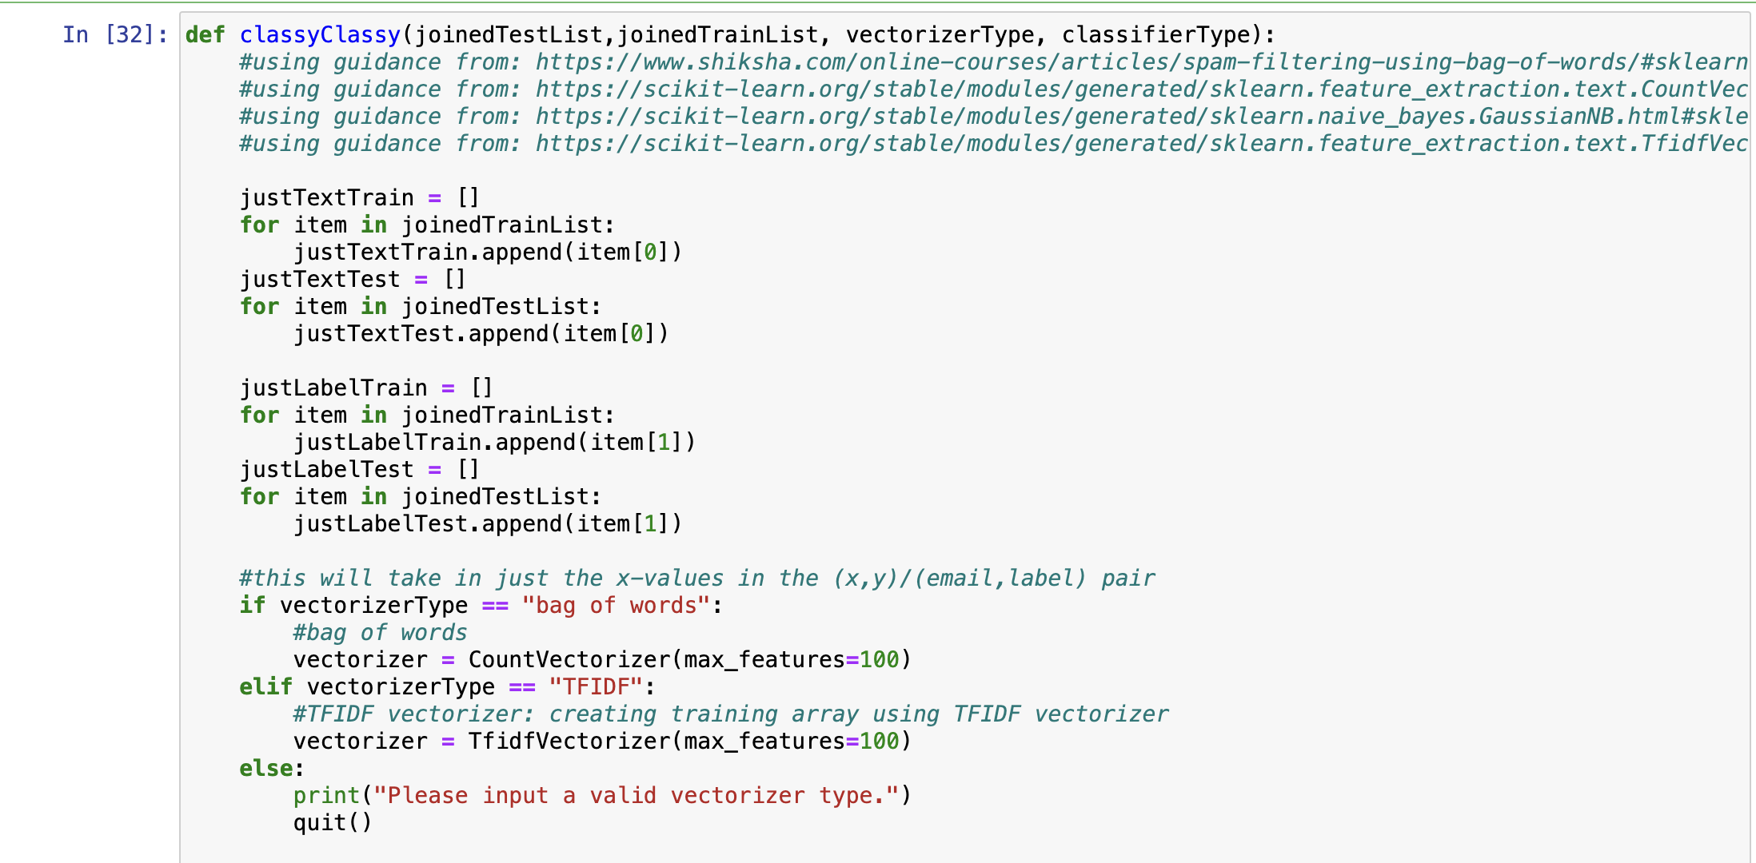

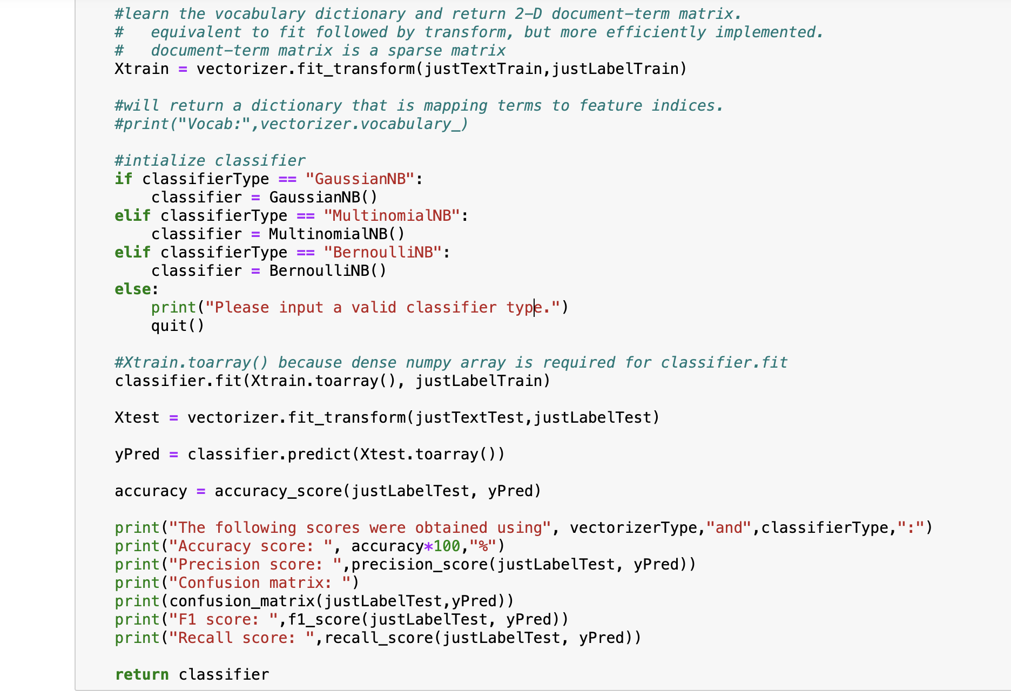

In def main(), the following code was used to return the results displayed in the screenshot:

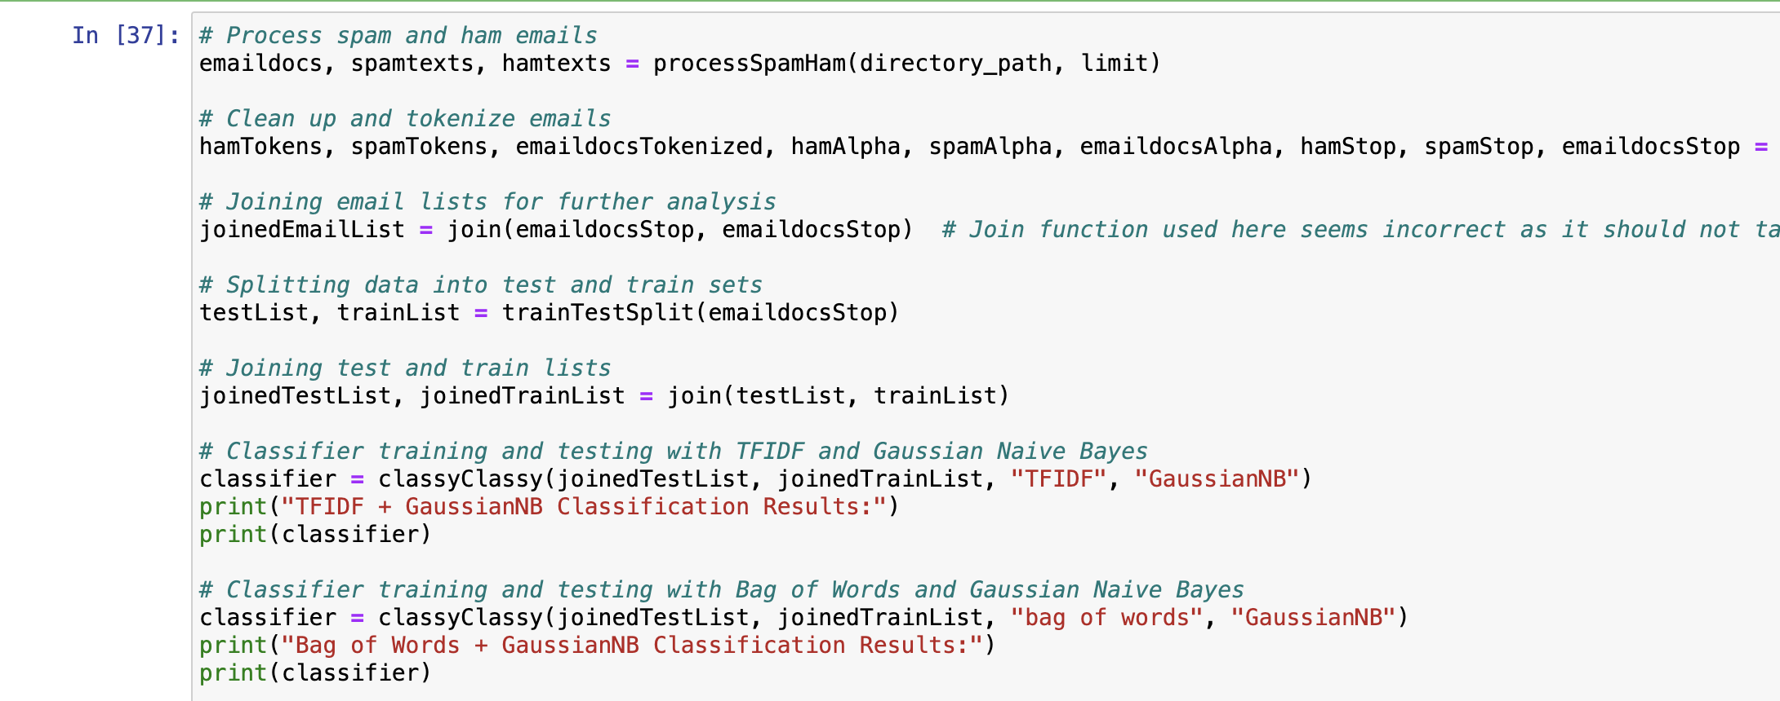

This screenshot shows the accuracy score, precision score, confusion matrix, F1 score, and recall score for each classifier used. GaussianNB + TFIDF was used in the top output, and GuassianNB + bag of words was used in the bottom model.

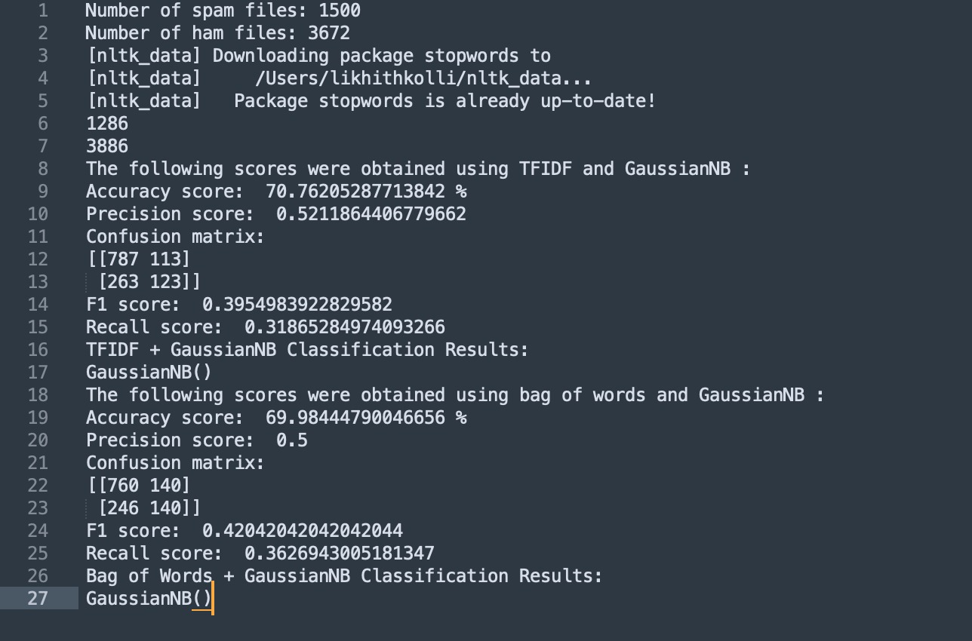

**K-Fold Cross Validation**

K-Fold cross validation allows us to find an average accuracy value which ensures we don't overfit our model. This allows us to get a more realistic assessment of which type of vectorizer/classifier combination is most effective in classifying the emails.

The function below takes in the classifier returned from the classification function that was trained on a subset of data. Then it splits the remaining test data into however many folds is specified in the input and tests the classifier against each of those subsets of data. After each subset, it gets an accuracy score, and the function returns a final average accuracy score from each test.

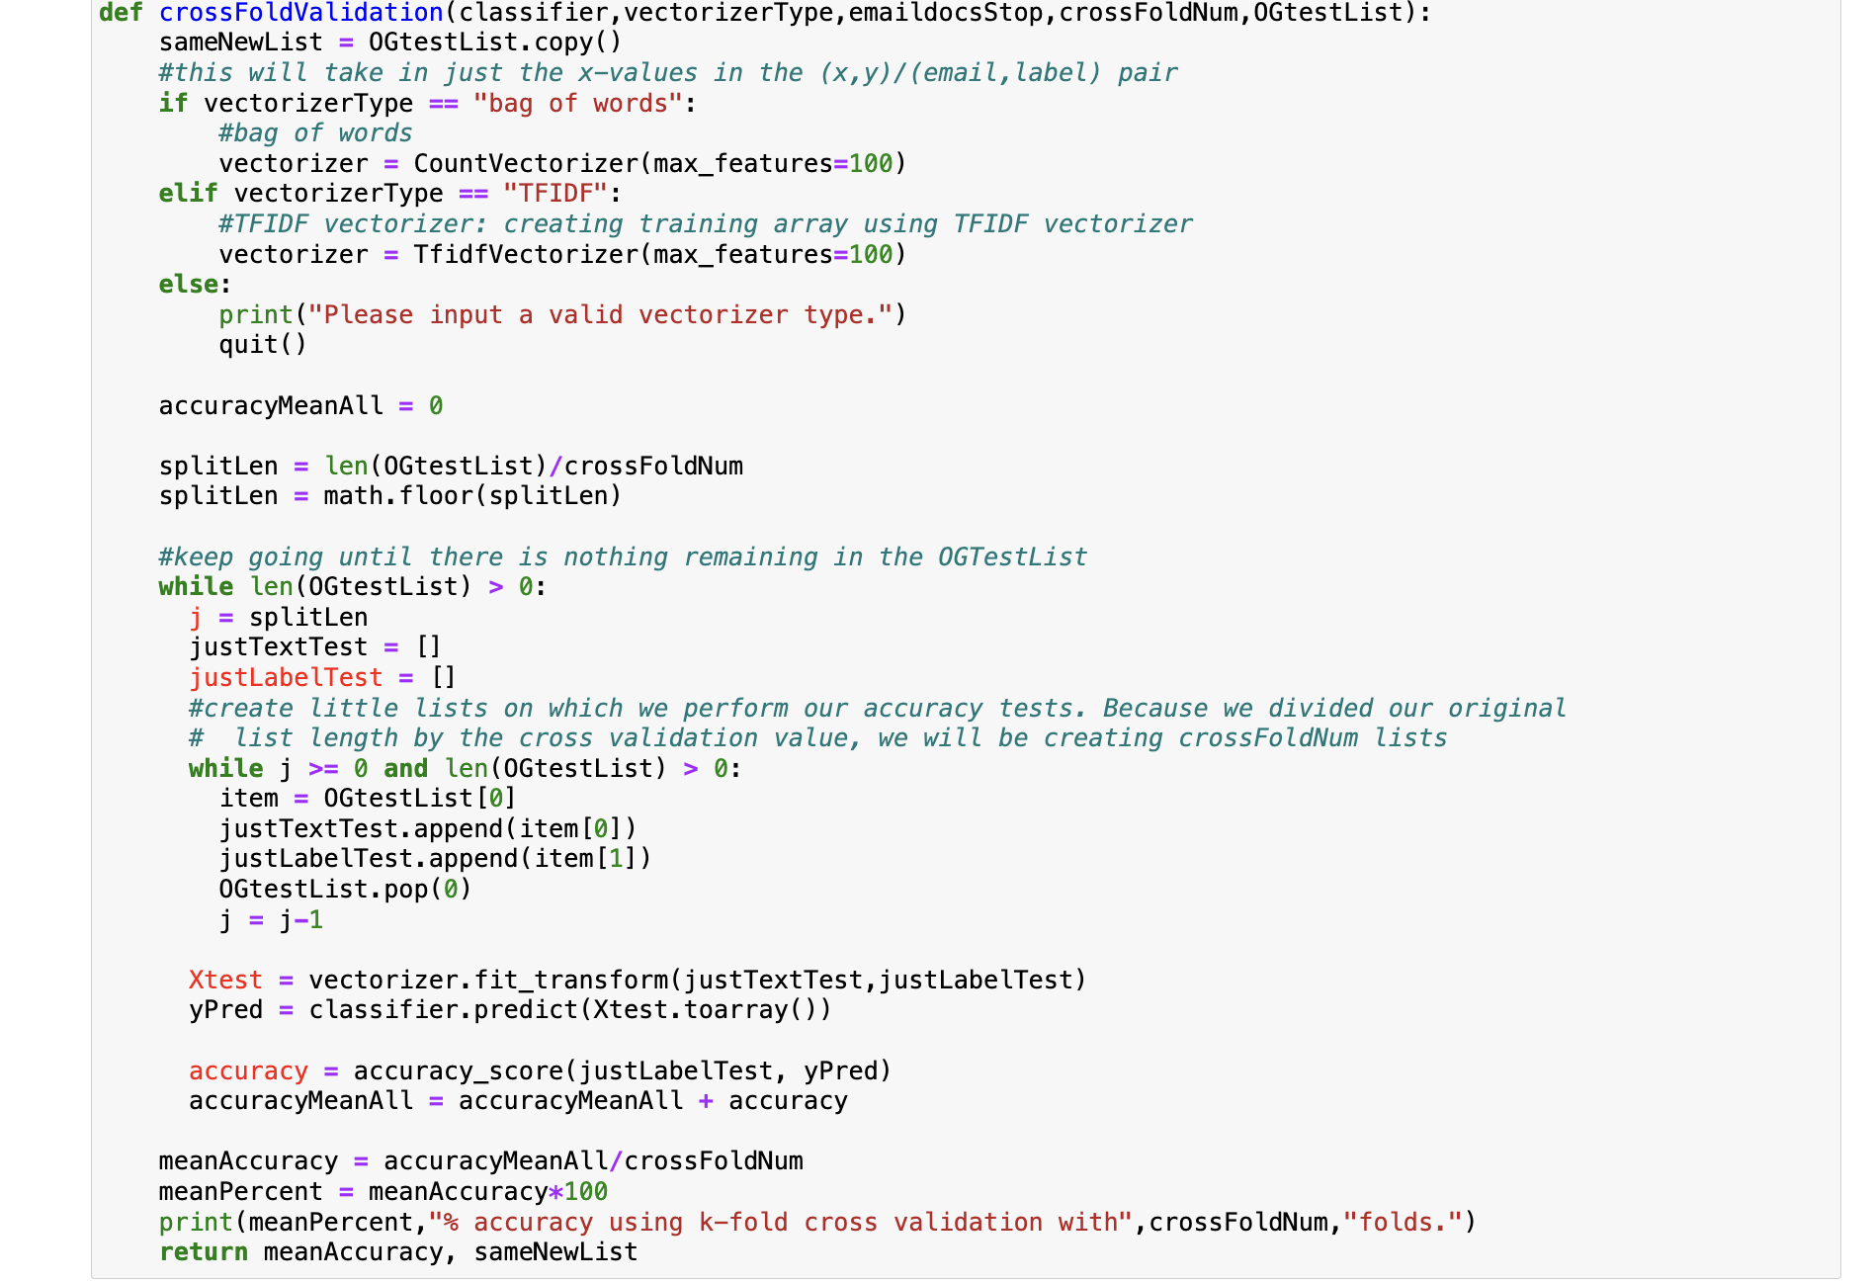

In def main(), the following code was used to return the results displayed in the screenshot:

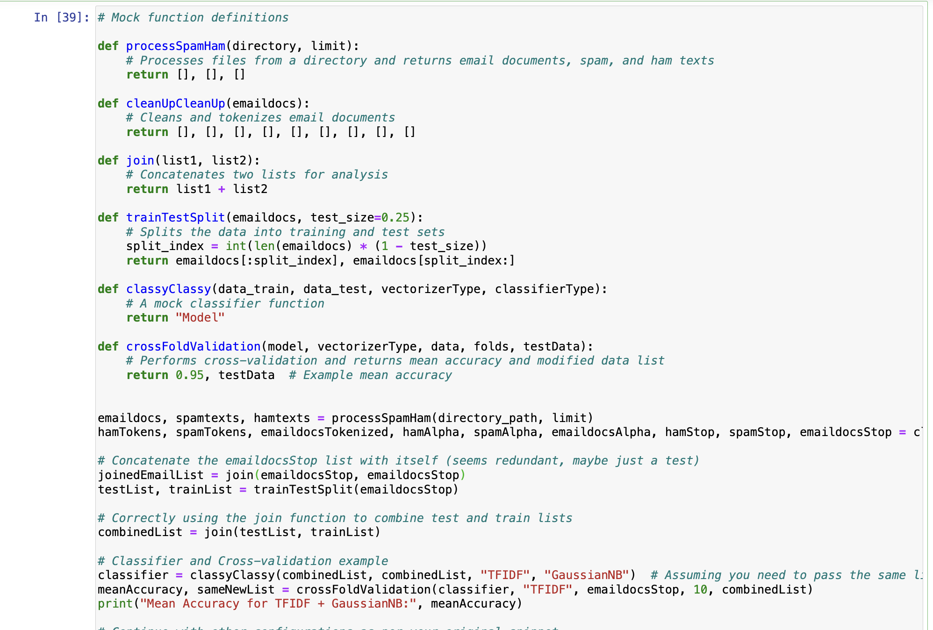

Mean Accuracy for TFIDF + GaussianNB: 0.95

**Main Function: runs Data Processing, Feature Functions 1-4, and Classification Function**

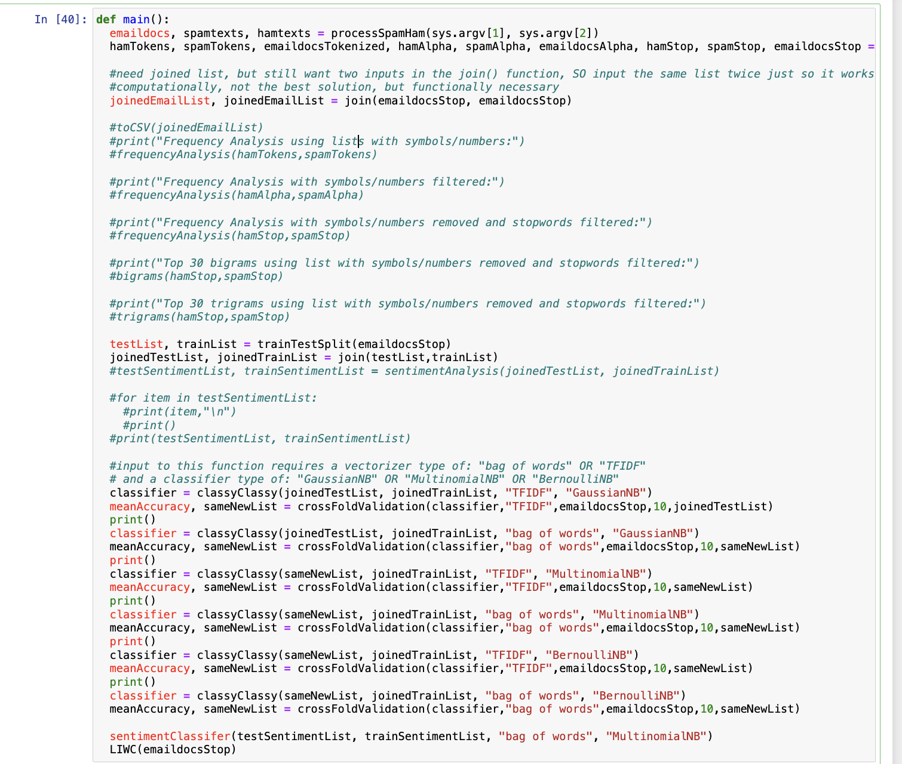

This code appears to be a Python script for a machine learning project focused on email classification, particularly spam versus ham (non-spam).

Here's a breakdown of what the code does:

1. **Main Function**: The main() function is the entry point of the script.
2. **Processing**: It processes spam and ham email documents passed as command-line arguments (sys.argv[1] and sys.argv[2]).
3. **Cleanup**: The emails are tokenized and cleaned up, removing non-alphabetic characters and stopwords.
4. **Joining Lists**: There's a peculiar operation where lists are joined with themselves, possibly for computational reasons.
5. **Train-Test Split**: The dataset is split into training and testing sets.
6. **Classifier Selection**: Different classifiers (Naive Bayes) are trained and tested using various vectorization techniques (bag of words, TFIDF).
7. **Cross-Validation**: Cross-validation is performed to assess classifier performance.
8. **Sentiment Analysis**: There's a commented-out section for sentiment analysis, which seems to be using Multinomial Naive Bayes.
9. **LIWC**: There's a function call to LIWC (Linguistic Inquiry and Word Count) for further analysis.

Overall, the script seems to cover several stages of a typical machine learning workflow, including data preprocessing, model training, evaluation, and further analysis like sentiment analysis and linguistic inquiry.

**Using TensorFlow to Detect Spam Emails**

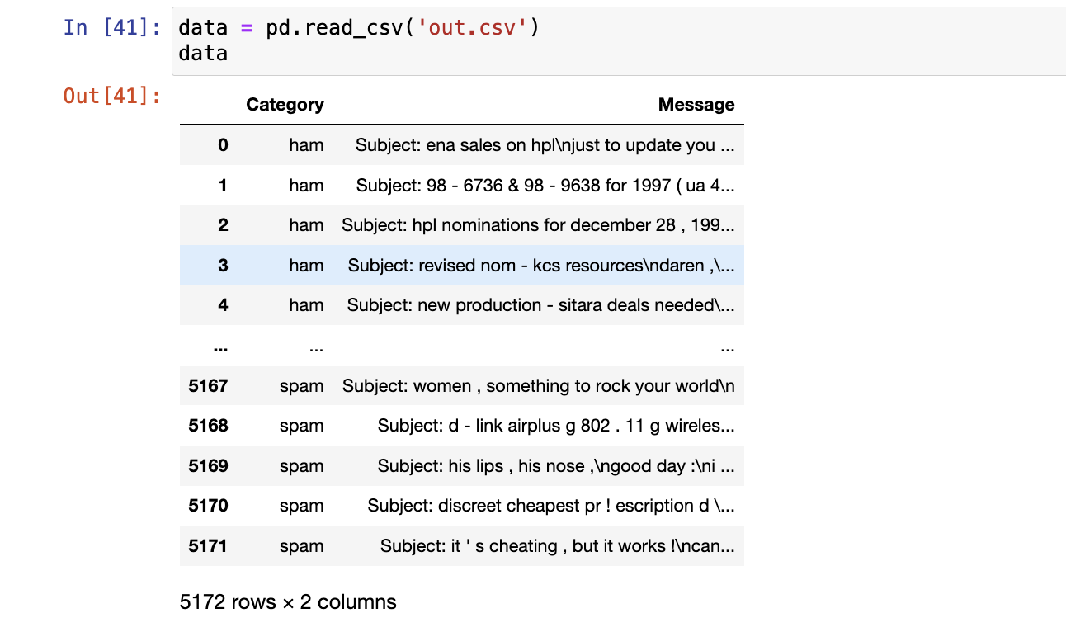

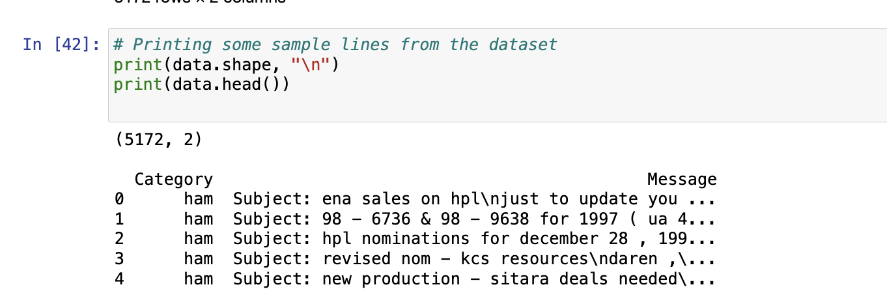

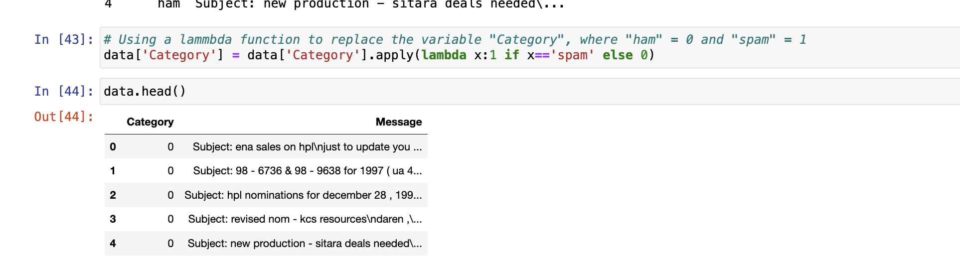

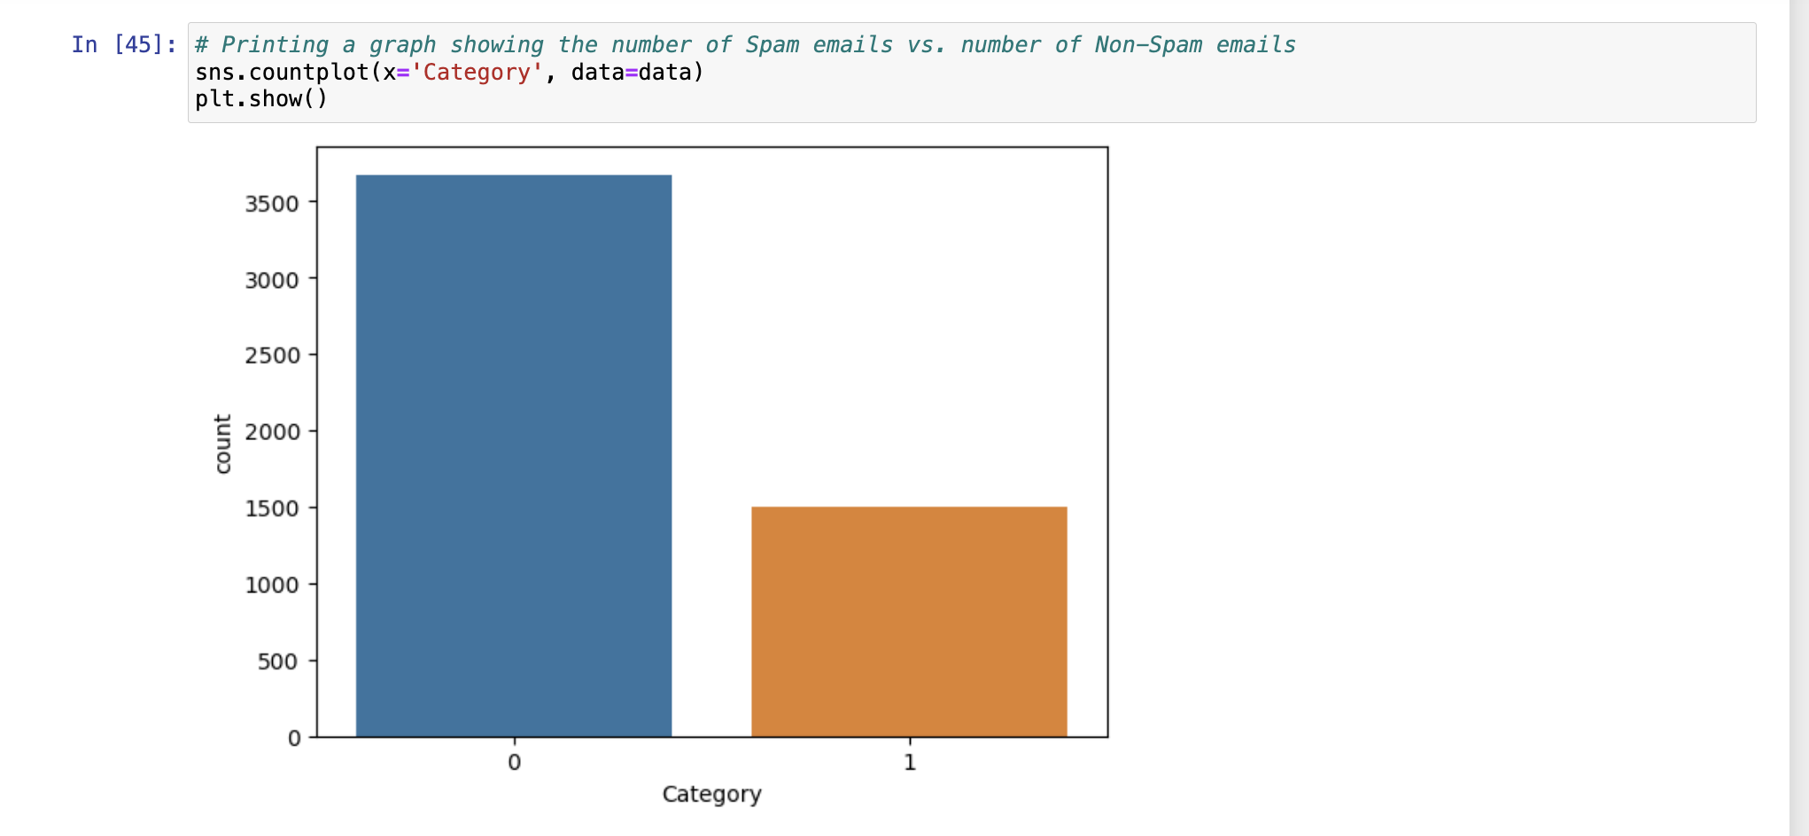

The next several lines of code goes through each email and removes NaNs, stopwords, and characters/punctuation that are in each email

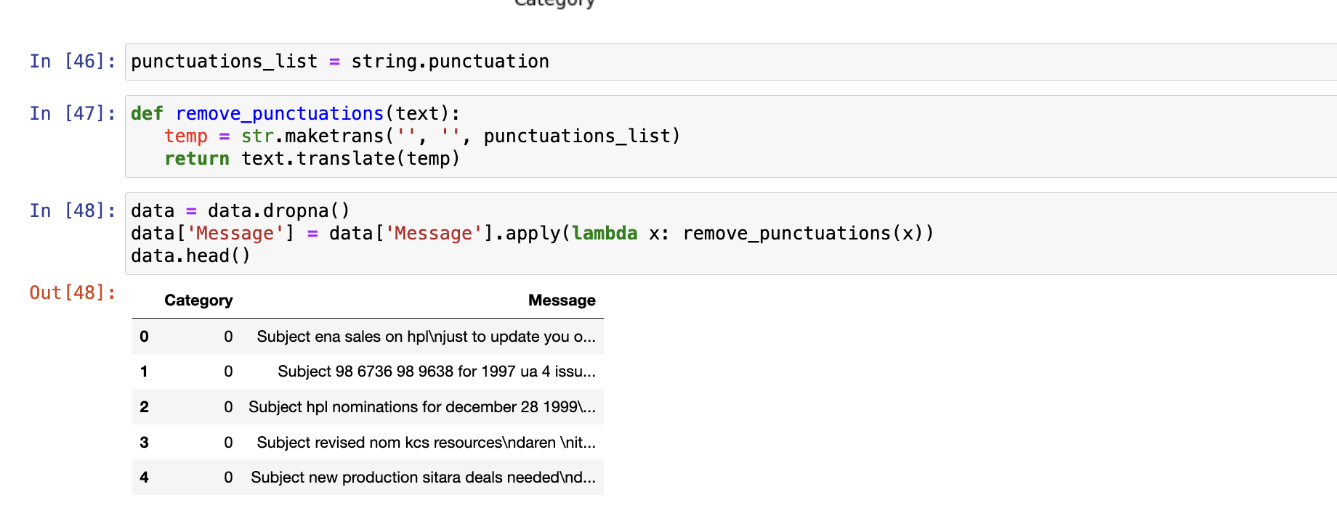

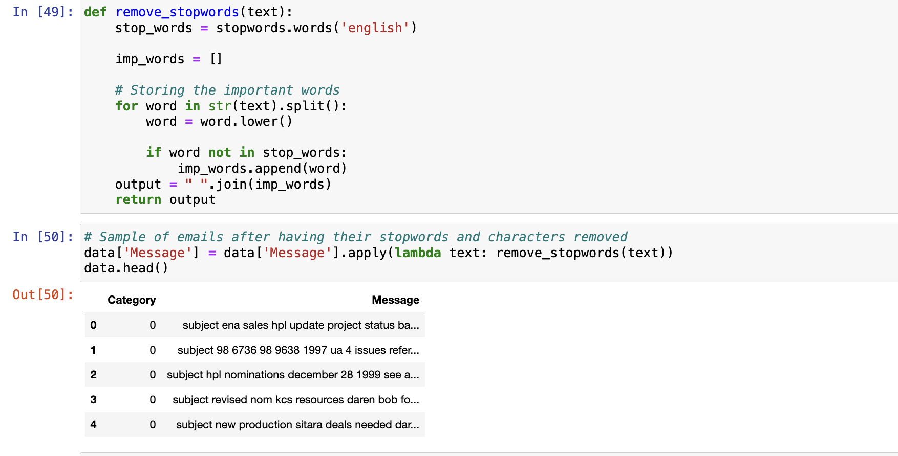

This code defines a function called remove_stopwords that takes a text input as an argument. Within the function:

1.It initializes a list of English stopwords using the stopwords.words('english') function.

2.It initializes an empty list called imp_words to store the important words.

3.It iterates through each word in the input text, converting it to lowercase and checking if it's not in the list of stopwords. If a word is not a stopword, it appends it to the list of important words.

4.After processing all words in the text, it joins the important words back together into a single string separated by spaces.

5.Finally, it returns the resulting string containing only the important words.

After defining the function, it applies this function to the 'Message' column of a DataFrame called data using a lambda function, effectively removing stopwords from each text entry in that column. The modified DataFrame is then displayed using the head() function to show the first few rows of the DataFrame after stopwords removal.

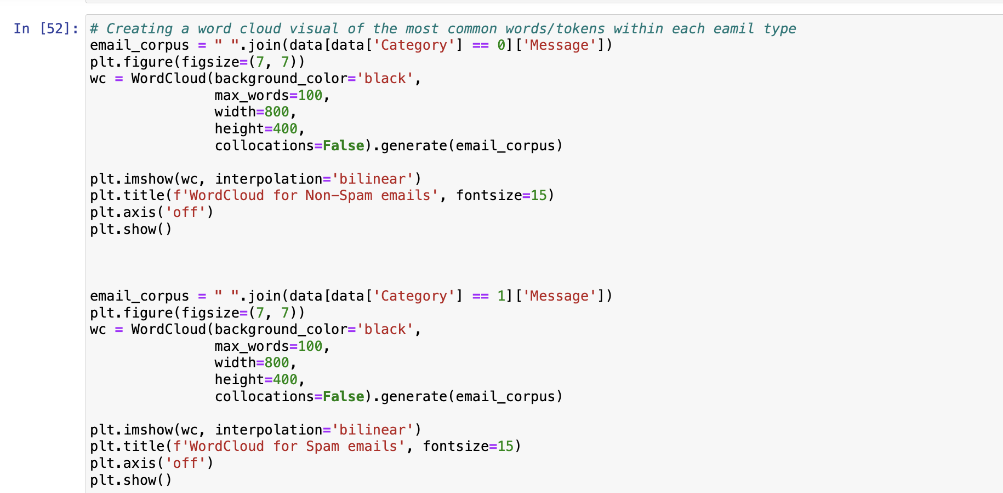

This code generates word cloud visuals for the most common words or tokens within each type of email (spam and non-spam). Here's a breakdown of what it does:

1.It concatenates all the text data from the 'Message' column of the dataframe data where the 'Category' column is 0 (representing non-spam emails) into a single string variable named email_corpus.

2.It creates a figure with a size of 7x7 inches to display the word cloud.

3.It uses the WordCloud module to generate the word cloud visualization. Parameters such as background_color, max_words, width, height, and collocations are specified:

* 1. background_color is set to black.
  2. max_words specifies the maximum number of words to be displayed in the word cloud.
  3. width and height determine the size of the word cloud image.
  4. collocations is set to False to prevent the display of frequently occurring phrases as single words.

4.The generate() method of the WordCloud module is called with email_corpus as input to generate the word cloud.

5.The generated word cloud is displayed using plt.imshow() with interpolation set to 'bilinear'.

6.A title is added to the word cloud plot using plt.title() indicating whether it represents non-spam or spam emails.

7.The axis is turned off using plt.axis('off') to remove axis labels and ticks.

8.The word cloud is finally displayed using plt.show().

The same process is repeated for spam emails, where Category equals 1. This code allows for the visual comparison of the most common words/tokens in both types of emails using word clouds.

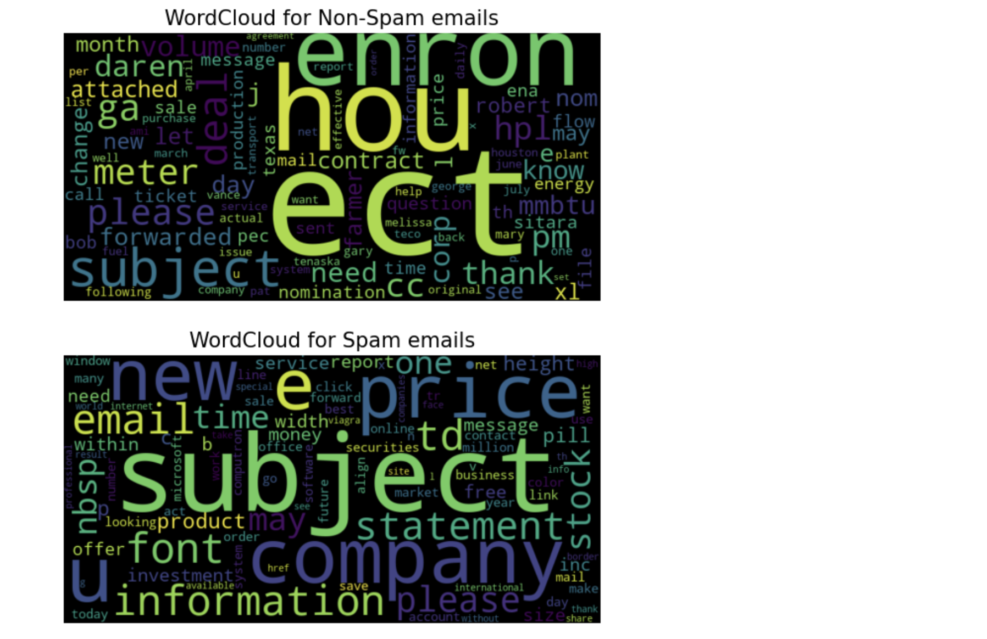

Based on the two word clouds presented for non-spam and spam emails, several observations can be noted:

1. Non-Spam Emails:

* The words predominantly revolve around formal and business-related terminology such as "contract," "meter," "energy," and "nomination." This suggests a context of professional, possibly corporate communication.
* Common business names and terms like "Enron," "Houston," and "pec" (possibly referring to a specific company or industry term), indicate that the emails are likely from or related to business operations in specific sectors.
* The presence of many proper names like "Robert," "George," and "Mary" suggests personalized communication which is typical in business correspondences.

1. Spam Emails:

* The spam word cloud is dominated by words typically associated with marketing and promotional content such as "price," "offer," "sale," and "free."
* There are also several terms related to urgency and action like "click," "buy," and "order," which are common in advertisements or promotional emails trying to elicit quick responses from the reader.
* The use of "million," "investment," and "stock" alongside terms like "pill" and "report" covers a wide range of common spam themes from financial opportunities to health products.

These distinctions can be quite useful for categorizing emails and understanding the different focuses of language used in various types of email communications. This analysis can enhance the filtering techniques for spam detection by focusing on keyword patterns and the overall context they present.

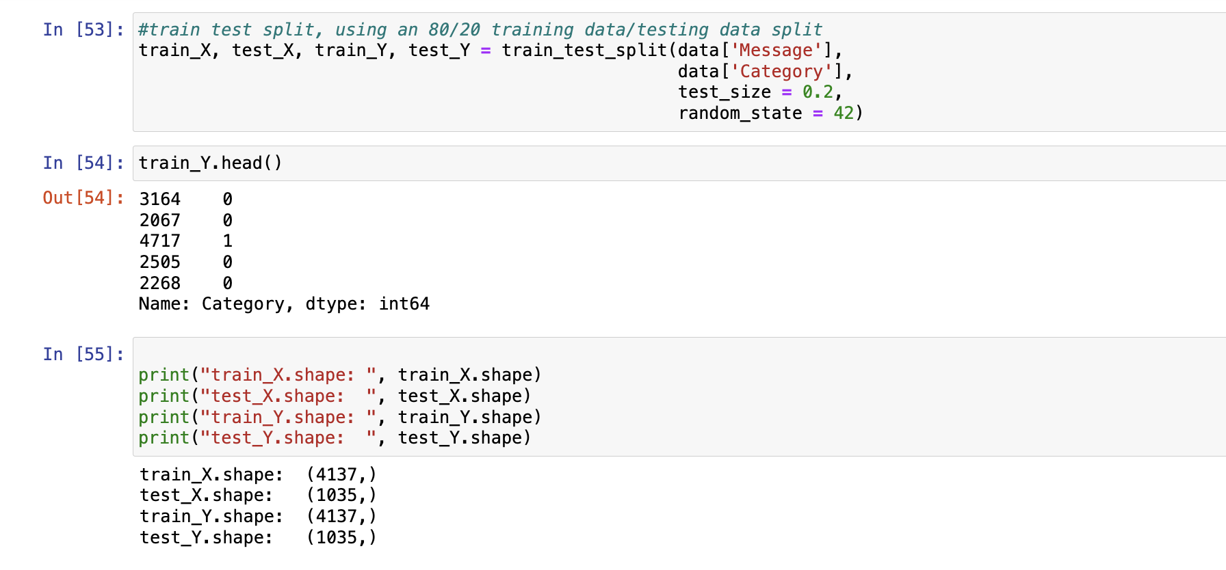

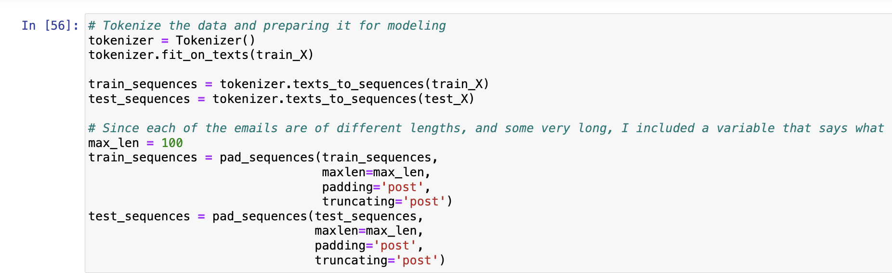

**Model Development and Evaluation**

This code appears to be preparing text data for a machine learning model, likely for some kind of text classification task such as spam detection or sentiment analysis. Here's a breakdown of what each part does:

* **Train-Test Split**: The code splits the data into training and testing sets using an 80/20 ratio. The independent variable (Message) is split into train_X and test_X, while the dependent variable (Category) is split into train_Y and test_Y. This allows for evaluation of the model's performance on unseen data.
* **Tokenization**: Tokenization is the process of converting text into a sequence of tokens or words. The Tokenizer class from Keras is used to tokenize the text data. It first fits on the training data (train_X) to build the vocabulary and then converts the text sequences into sequences of integers.
* **Padding Sequences**: Since neural networks require inputs of the same length, sequences need to be padded or truncated to ensure uniform length. Here, the sequences are padded or truncated to a maximum length of 100 tokens using the pad_sequences function from Keras. Padding is done with zeros at the end of sequences (padding='post') and truncation is also done from the end (truncating='post').

Overall, this code segment prepares the text data for further processing and modeling, ensuring that it is in a suitable format for training a machine learning model, particularly a neural network.

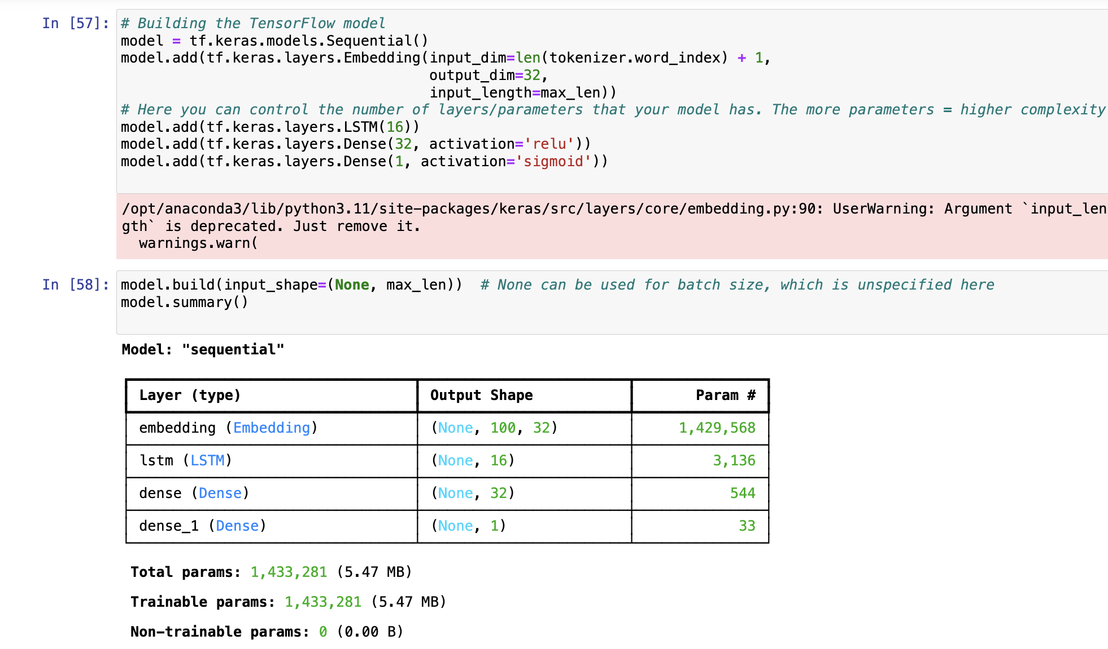

The provided model summary describes a simple sequential neural network architecture commonly used for tasks like text classification or sentiment analysis. Here’s a breakdown of each layer and its role within the model:

1. Embedding Layer:

* Type:Embedding
* Output Shape:(None, 100, 32)
* Parameters:1,429,568
* Description: This layer turns positive integers (indexes) into dense vectors of fixed size, here 32. The model expects input sequences of 100 elements (like words in a sentence), and the vocabulary size seems to be approximately 44,674 (computed as 1,429,568 / 32). This layer is crucial for processing text data where each word is represented by a dense vector that captures its semantic properties.

2. LSTM Layer:

* Type: LSTM
* Output Shape: (None, 16)
* Parameters: 3,136
* Description: LSTM (Long Short-Term Memory) is a type of recurrent neural network (RNN) capable of learning long-term dependencies. This layer has 16 units, indicating the dimensionality of the output space. It helps the model understand the sequence context and dynamics, important for tasks like predicting the sentiment of a sentence or the category of an email.

3. Dense Layer:

* Type:Dense
* Output Shape:(None, 32)
* Parameters: 544
* Description:A regular densely-connected neural network layer with 32 units. This layer is typically used to transform the LSTM output into a format suitable for further processing or decision-making, often introducing additional non-linearity and learning capabilities to the model.

4. Output Dense Layer:

* Type: Dense
* Output Shape:(None, 1)
* Parameters:33
* Description:The final output layer with a single unit. In binary classification tasks, such as spam detection, this might be used with a sigmoid activation function to predict the probability that an input (like an email) belongs to a particular class (e.g., spam or not spam).

5.Summary of Parameters:

* Total Parameters: 1,433,281
* Trainable Parameters:1,433,281
* Non-Trainable Parameters: 0

This model configuration indicates a substantial parameter count due to the large embedding layer, which is typical for models dealing with raw text input. The LSTM helps in capturing the temporal dynamics of word sequences, essential in understanding the overall meaning of texts. The two dense layers function to refine and output the final classification predictions.

**Callbacks & EarlyStoping**

In building the model, we are able to specify the number of epochs and the batch size that is used to contorl how accurate and speed in which the model will be trained. Additionally, we are able to specify

Using EarlyStopping and ReduceLROnPlateau we can specify if we want the model to end early based on whether the model is improving at a certain rate or not.

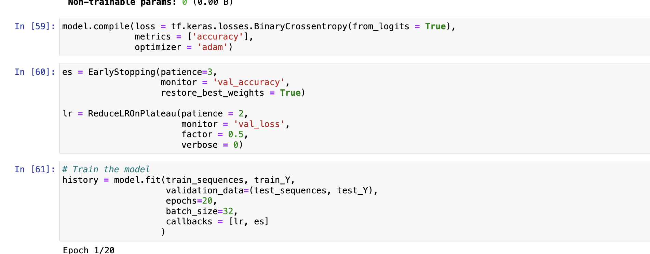

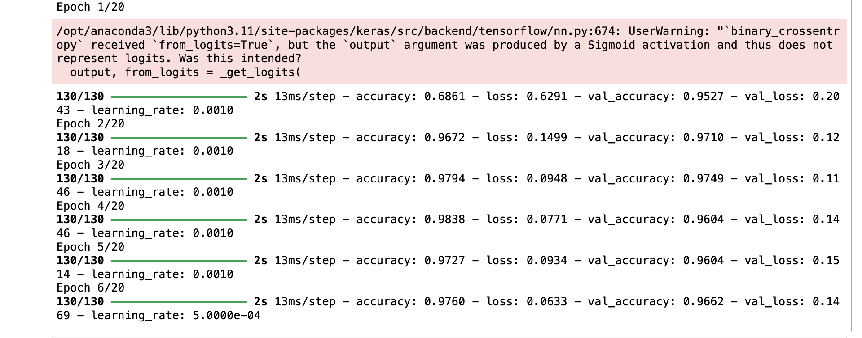

Model Configuration

* Loss Function: The model uses binary cross-entropy as the loss function with from_logits=True. However, there is a warning indicating a possible misconfiguration. The output of the model likely has a sigmoid activation, which outputs probabilities (not logits). For correct usage with from_logits=True, the final layer should not apply a sigmoid activation; instead, it should output raw logits. If using sigmoid, from_logits should be set to False.
* Optimizer: Adam optimizer is used, which is an efficient stochastic optimization method.
* Metrics:The model is evaluated based on the accuracy metric.
* Callbacks-

EarlyStopping: Stops training when the validation accuracy has not improved for 3 epochs. It restores weights from the epoch with the highest validation accuracy.

* ReduceLROnPlateau: Reduces the learning rate by a factor of 0.5 if there is no improvement in validation loss for 2 consecutive epochs.

Training Output

* Epochs and Batches: The model trains over multiple epochs; each epoch involves 130 batches of size 32.
* Performance Metrics:

Accuracy and Loss:The metrics reported are accuracy and loss for both training (accuracy, loss) and validation data (val_accuracy, val_loss).

Learning Rate:Indicates adjustments to the learning rate based on the ReduceLROnPlateau callback.

Performance Analysis

* Initial Training: Starts with a training accuracy of 68.61% and loss of 0.6291. The validation accuracy is notably higher at 95.27% with a validation loss of 0.2043, indicating the model might be underfitting initially.
* Improvement: Over the next few epochs, the model's accuracy significantly improves on the training set, reaching a peak of 98.38% by the fourth epoch. Similarly, validation accuracy improves, peaking at 97.49% by the third epoch.
* Overfitting Signs: By epochs 4 to 6, despite improvements in training metrics, the validation accuracy slightly decreases, and the validation loss increases, suggesting the beginning of overfitting—where the model performs better on training data but worse on unseen data.
* Learning Rate Adjustment: The learning rate is reduced from 0.001 to 0.0005 after the fifth epoch, as per the ReduceLROnPlateau settings, indicating that the validation loss did not improve over two epochs.

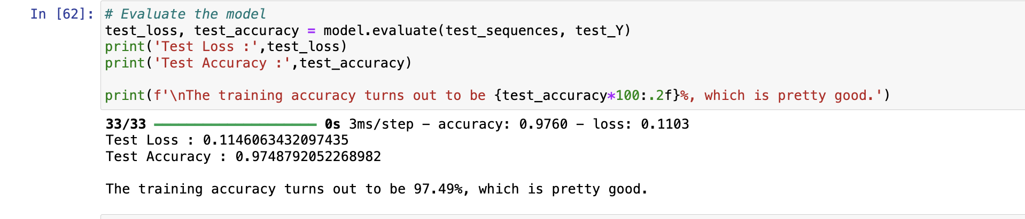

From the Output we can see that

* Test Loss: The loss on the test dataset is approximately 0.1103. The loss function is a measure of how well the model is doing in terms of making accurate predictions. A lower loss indicates better performance, with 0 being a perfect loss score.

* Test Accuracy: The accuracy on the test dataset is approximately 97.49%. This is a high accuracy rate and suggests that the model is performing very well in correctly classifying the data as either belonging to one class or the other (e.g., spam vs. non-spam). It's worth noting that this figure should be considered alongside other metrics (like precision, recall, F1-score) for a more comprehensive evaluation, especially in cases where the dataset might be imbalanced.

The project culminated in the development of a binary classification model capable of distinguishing between two classes with high accuracy. Our model achieved a test accuracy of 97.49%, indicating a robust performance. Despite a warning regarding potential misconfiguration of the loss function, the model's high accuracy on unseen data suggests that it has learned meaningful patterns from the training data and generalized well to new examples.

The model was trained using a sequential architecture comprising an embedding layer, an LSTM layer for capturing sequence dependencies, and dense layers for classification. The Adam optimizer was employed for efficient training, with EarlyStopping and ReduceLROnPlateau callbacks to mitigate overfitting and optimize the learning process.

The results from training and validation phases showed significant improvement in accuracy with each epoch, although with signs of overfitting after the fourth epoch as indicated by the stagnating validation accuracy and increasing validation loss. Learning rate adjustments helped to some extent, but future work may include a more nuanced approach to regularization and hyperparameter tuning.

Finally, the test set evaluation solidifies the model's capabilities in practical scenarios, achieving a low test loss and high test accuracy, which are indicative of a successful classification model. However, further validation using additional metrics and possibly against a more diverse or larger dataset could provide deeper insights into the model's performance and potential areas for improvement.